Visoka škola strukovnih studija za informacione i komunikacione tehnologije



DOKUMENTACIJA

Gabrijela Matovic 21/18

SADRZAJ

UVOD

1. Korisceni programski jezici
2. Opis funkcionalnosti
3. Template
4. Korisceni CSS

ORGANIZACIJA

1. Organizaciona sema
2. Sitemap
3. Slike stranica sa opison funkcionalnosti
4. Robots

KODOVI

1. HTML
2. CSS
3. JS / JQuery
4. JSON

UVOD

1. KORISCENI PROGRAMSKI JEZICI

* HTML
* CSS
* JS / JQuery
* Boostrap
* SCSS

1. OPIS FUNKCIONALNOSTI

* Header : dve editovane slike se smenjuju na 3 sekunde
* Products : proizvodi ispisani dinamicni pomocu JS i AJAX-a. Filtriranje odradjeno pomocu local storage-a.
* Kontakt forma za porucivanje proizvoda validirana pomocu JS.
* Funkcija openNav() preuzeta sa prosledjenog linka i dodatno modifikovana <https://www.w3schools.com/howto/howto_js_sidenav.asp>

1. TEMPLATE

Template nije korišćen iz drugih izvora, napisan je samostalno.

1. DODATNI CSS

* Animate CSS
* SweetAlert
* Kod oznacen crvenom bojom pri stilizovanju search bara

ORGANIZACIJA

1. ORGANIZACIONA SEMA

Moze se pristupiti svim linkovima unutar stranice

1. SITEMAP

<?xml version="1.0" encoding="UTF-8"?>

<urlset xmlns="http://www.sitemaps.org/schemas/sitemap/0.9">

<url>

<loc> <https://geerishappyfish.000webhostapp.com/></loc>

<lastmod> 2020-03-27 </lastmod>

<changefreq> monthly </changefreq>

<priority> 0.8 </priority>

</url>

</urlset>

1. SLIKE STRANICA SA OPISON FUNKCIONALNOSTI

* Slike headera koje se smenjuju odradjene pomocu JS

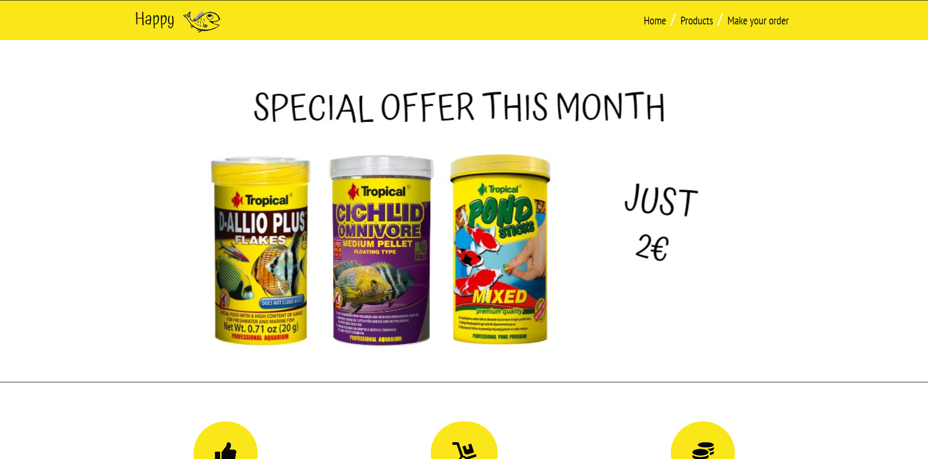

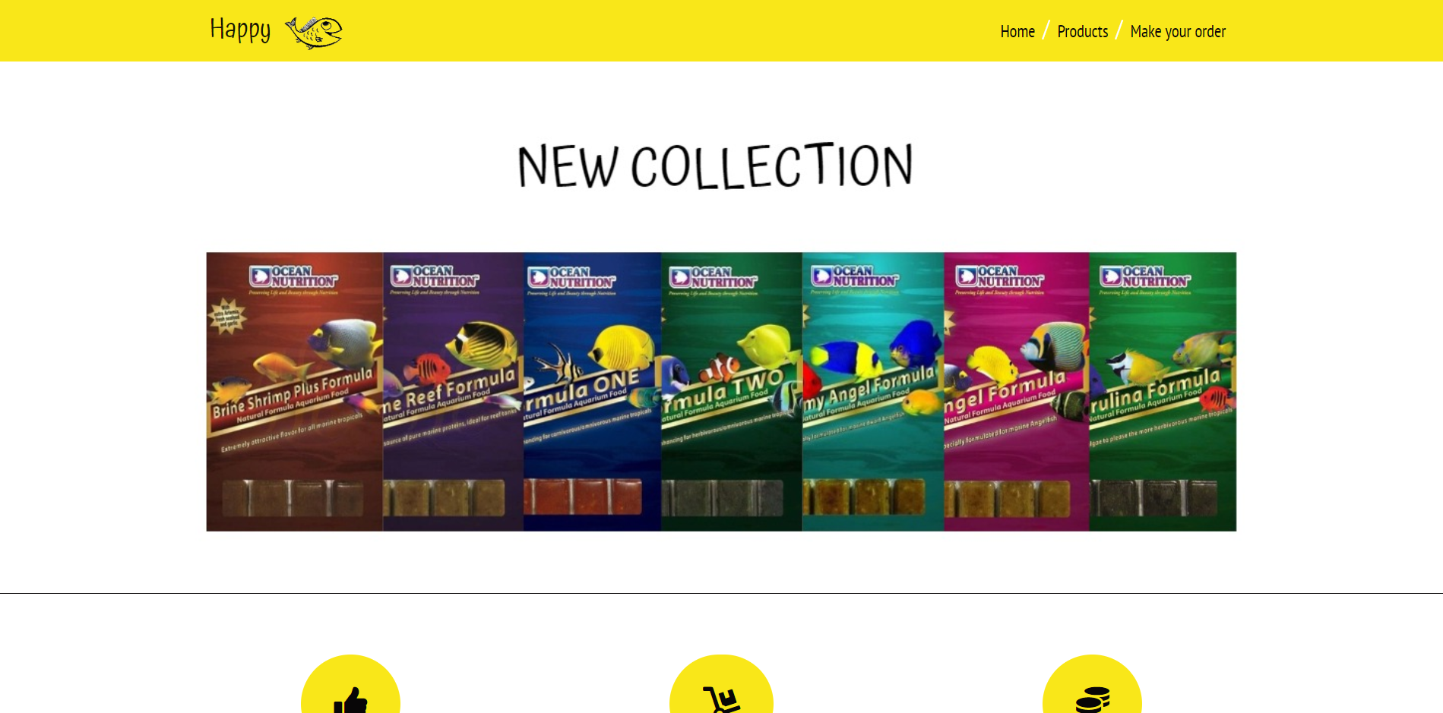

* Logo animiran pomocu animate CSS



* Ikonice usluga animirane pomocu animate CSS



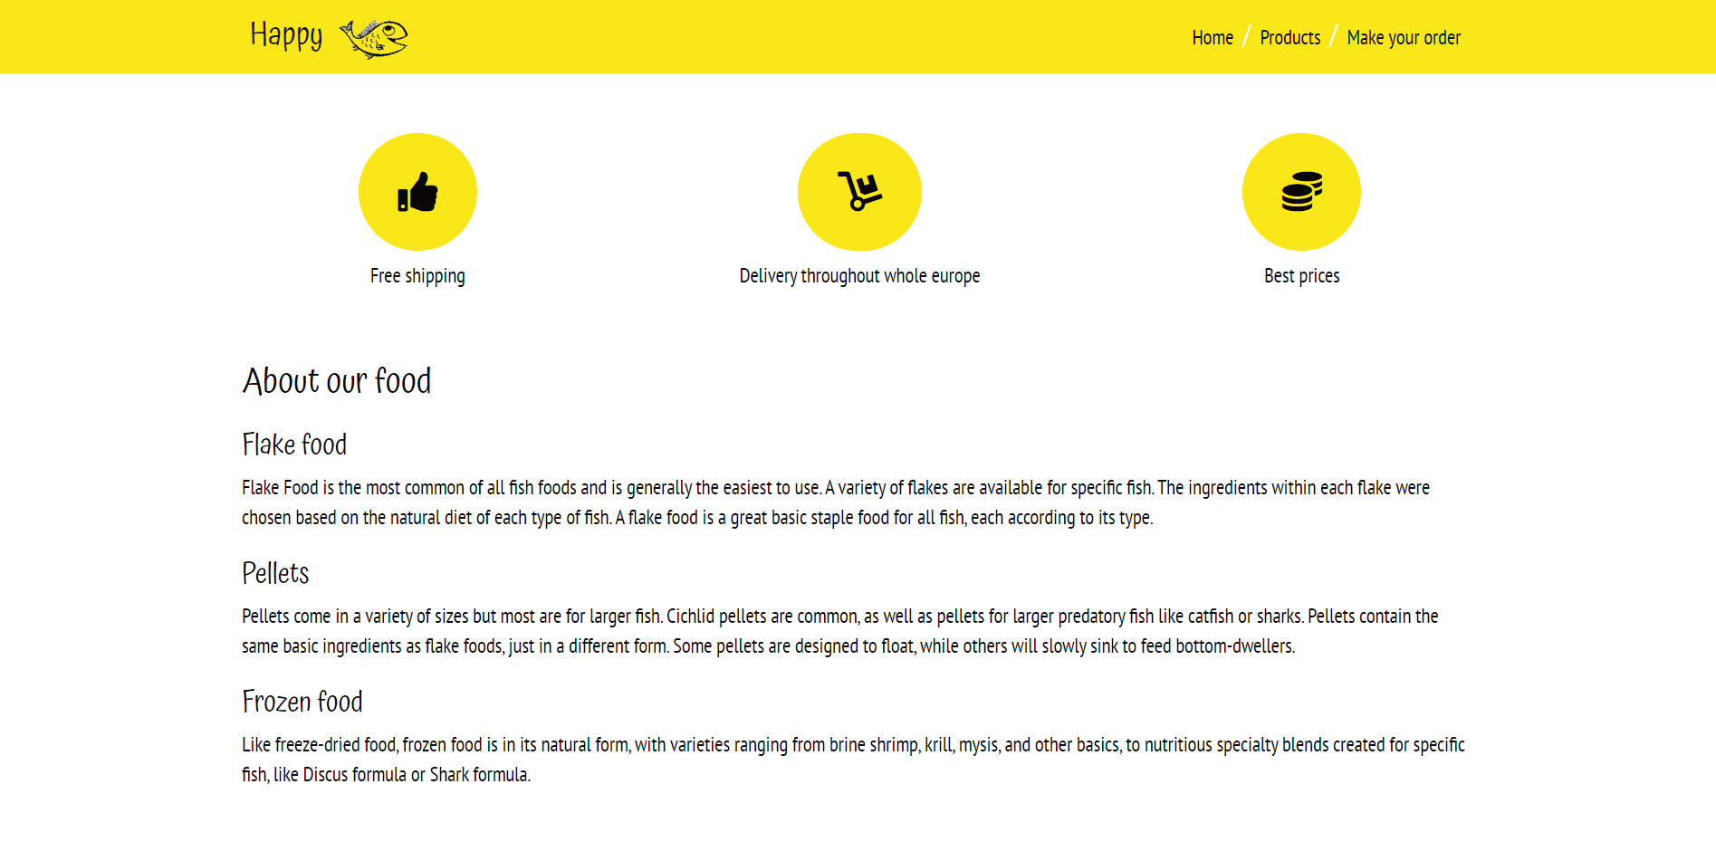

* Proizvodi ispisani dinamicki pomocu JS i AJAX-a sa JSON fajlom

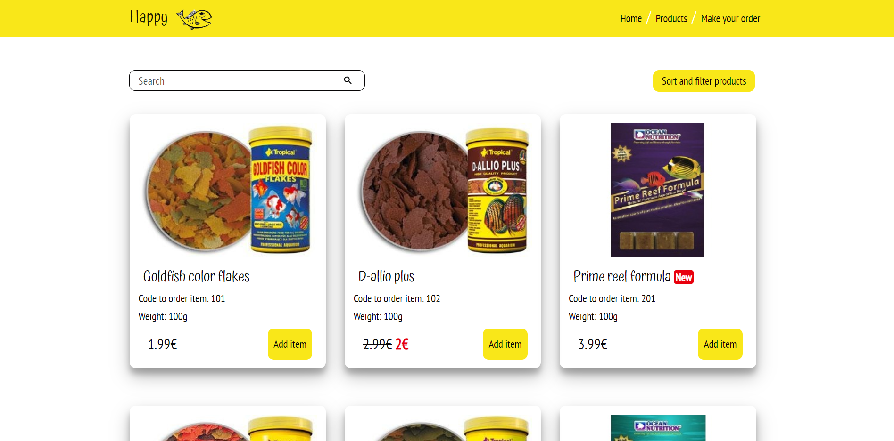

* Prozor za filtriranje i sortiranje proizvoda koji se otvara klikom na *Sort and filter products.*

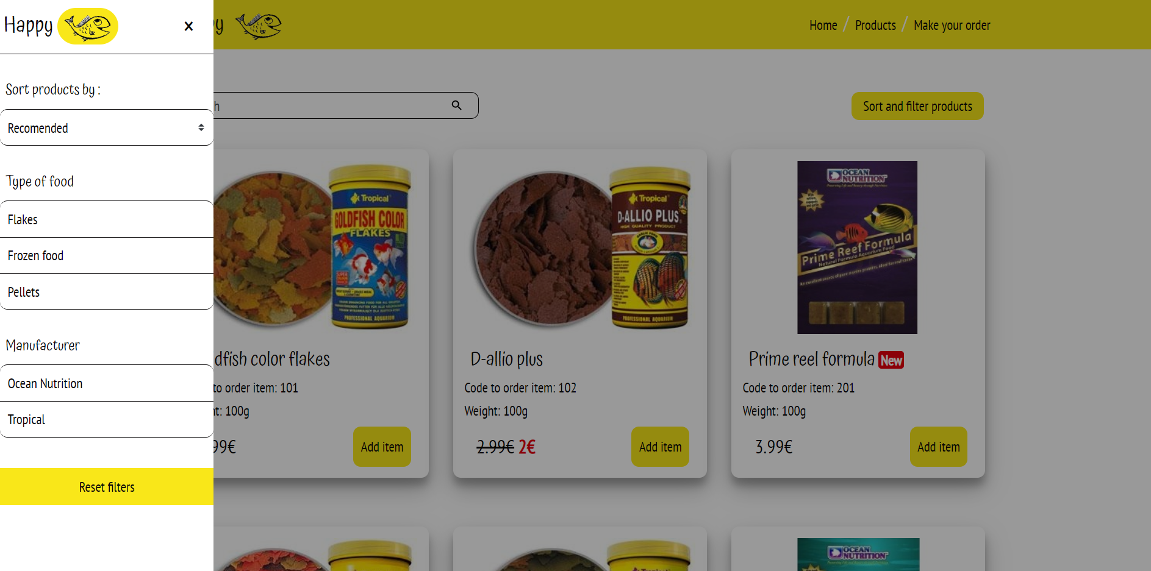

* Moze se izabrati samo jedan iz grupe filtera po tipu hrane i proizvodjacu

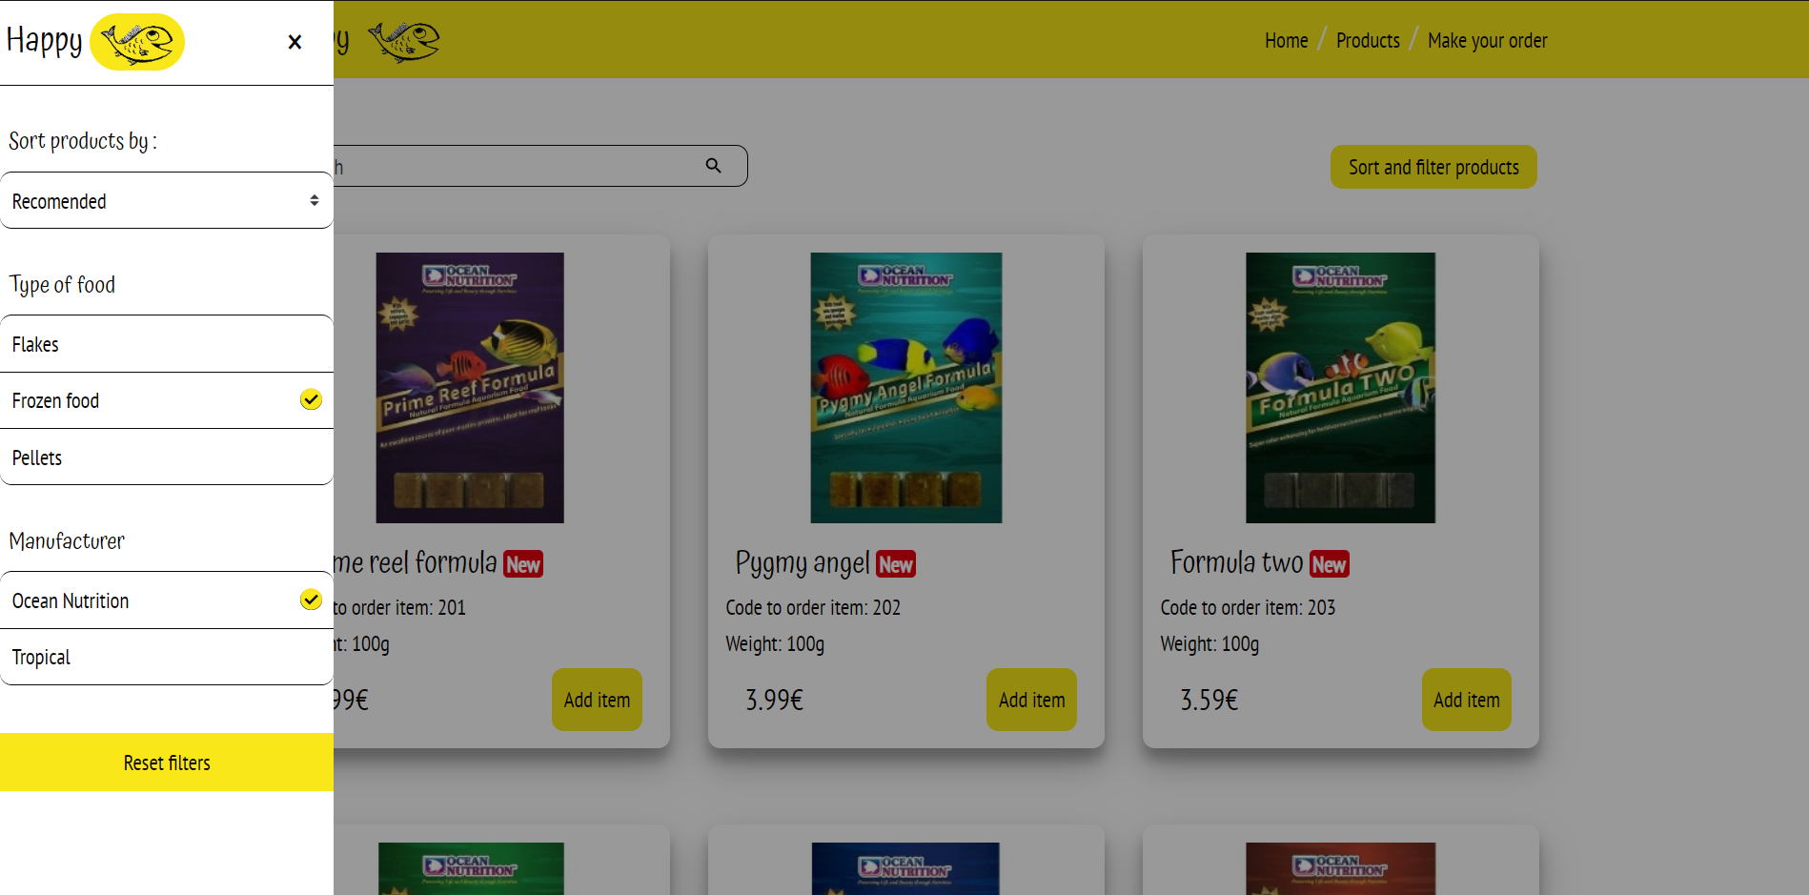

* Ukoliko nema rezultata pretrage, pojavice se poruka na mestu proizvoda

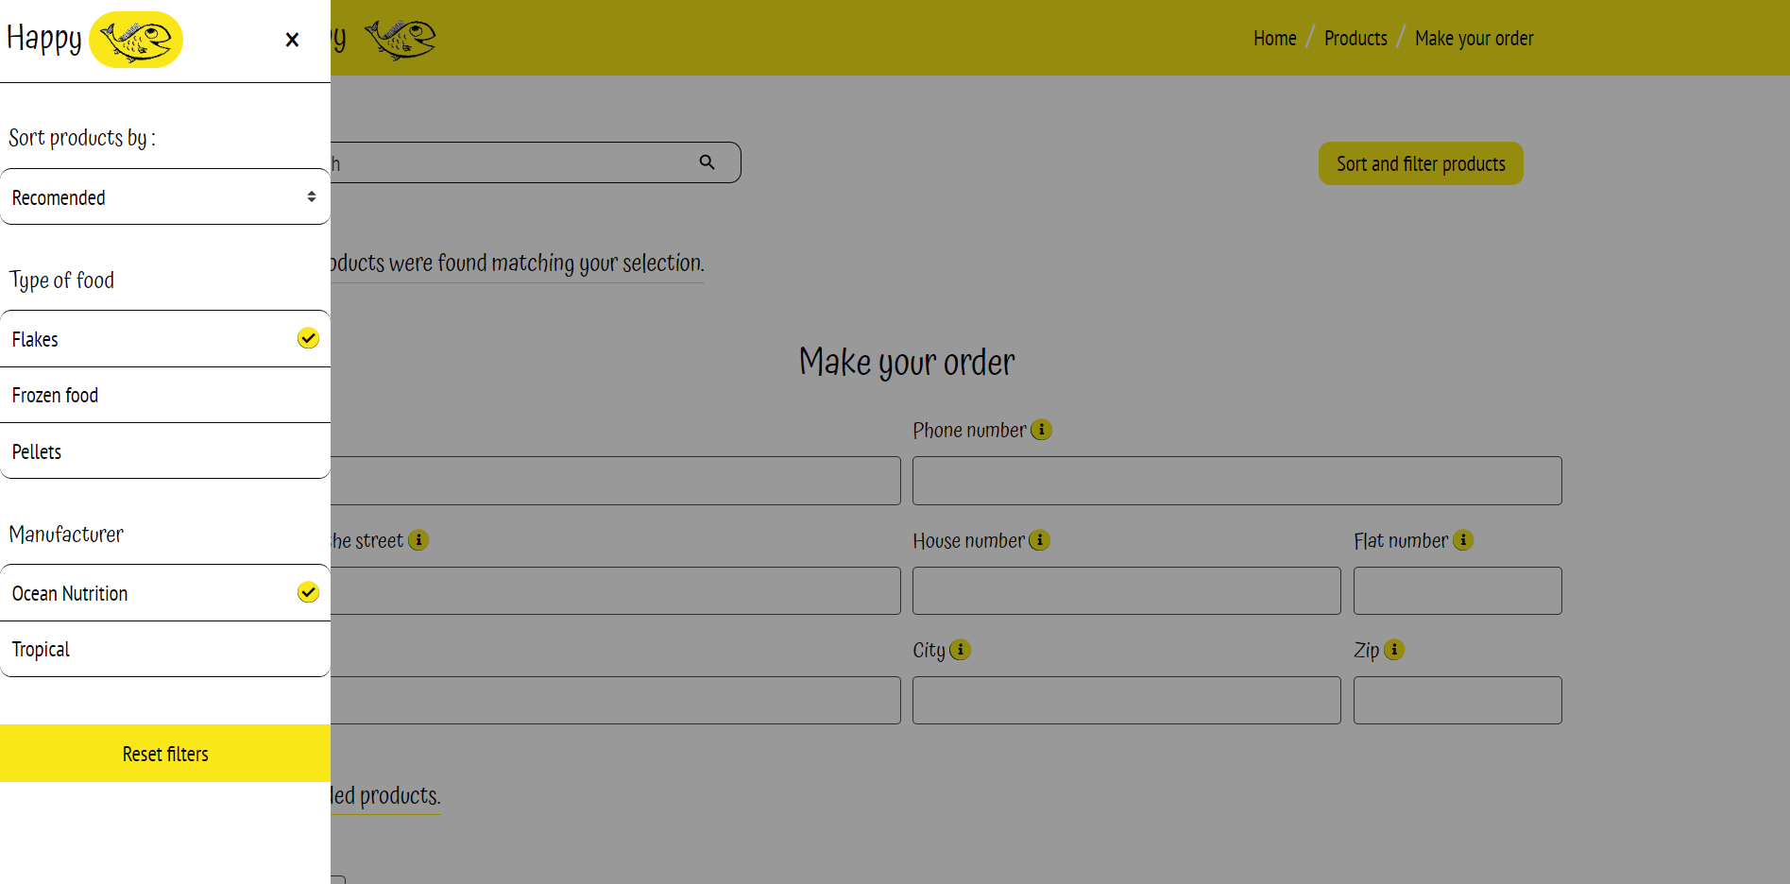

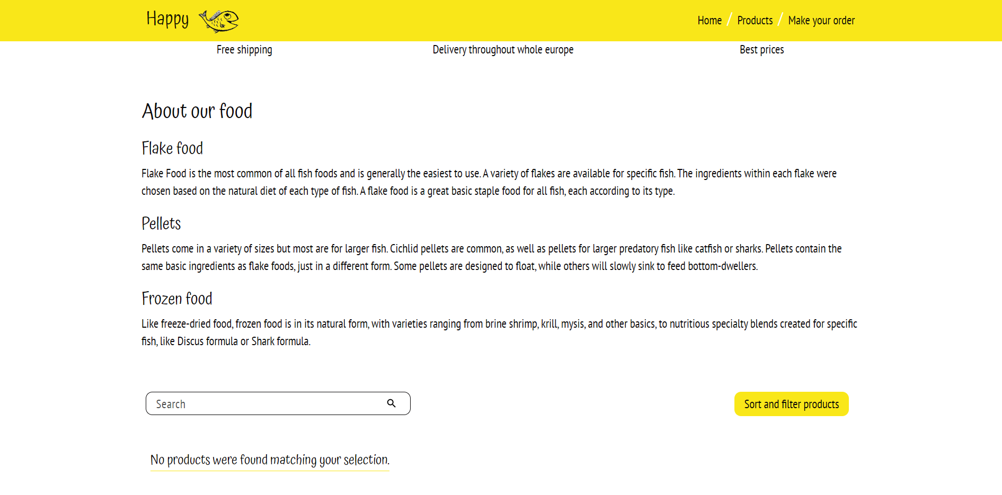

* Klikom na *reset products* se brisu svi filteri i sortiranja izabrana do tada
* Moguce je sortiranje po ceni u rastucem i opadajucem redosledu

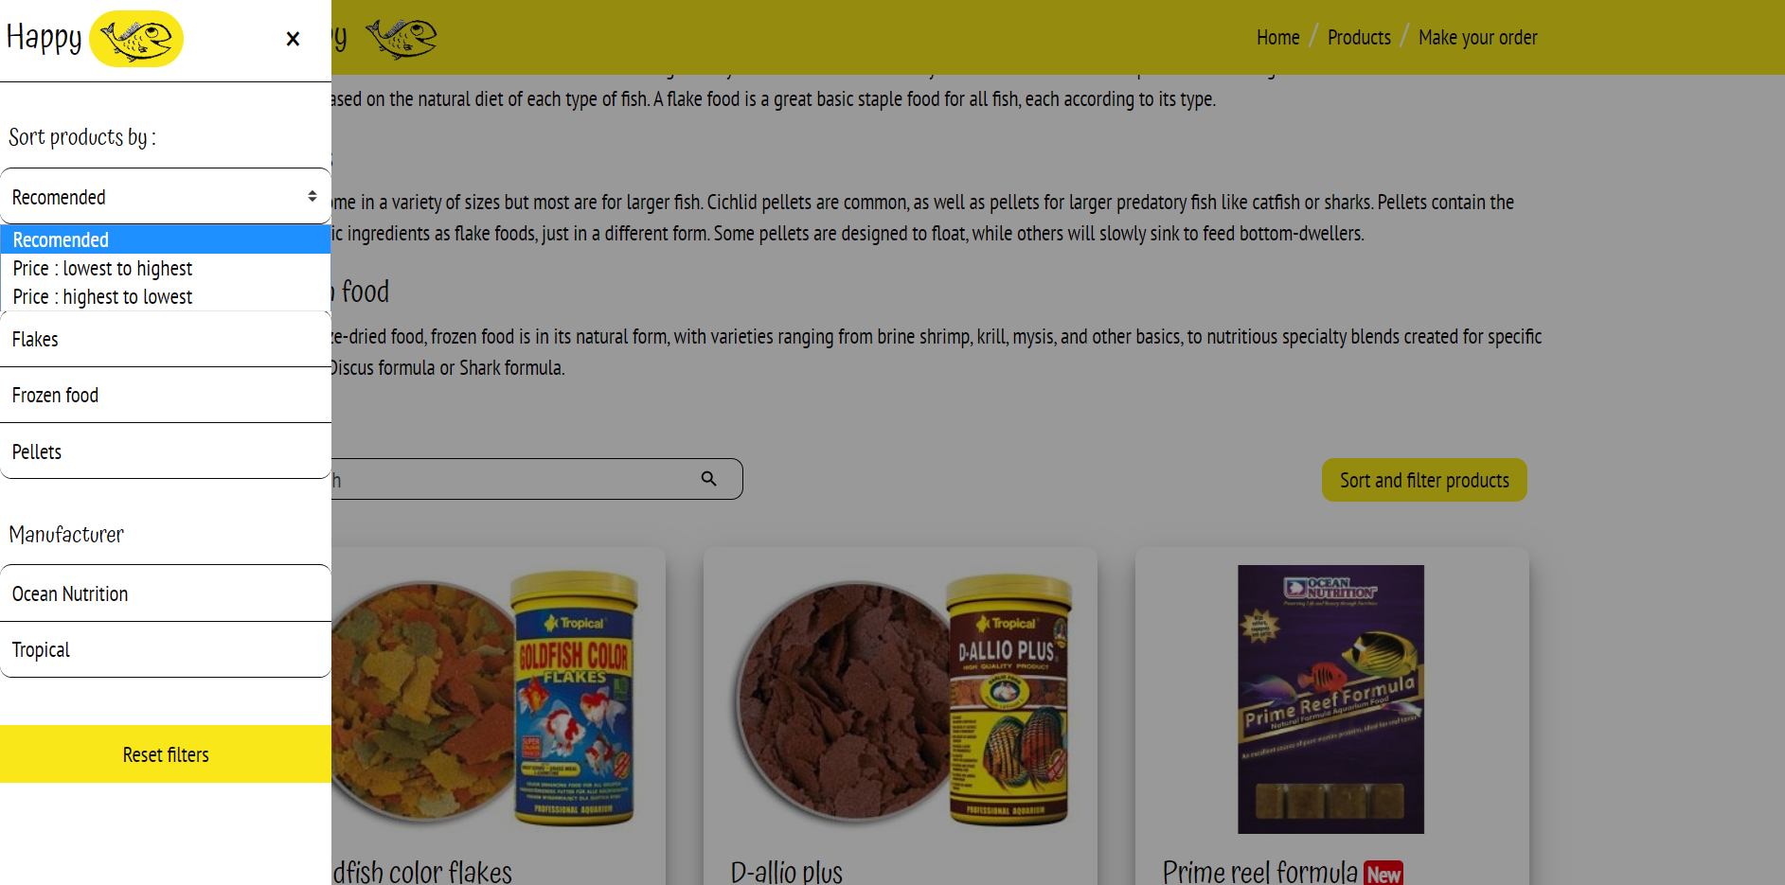

* Moguce je i filtriranje pomocu search bara. *Reset filters* ce obrisati i pretragu po imenu

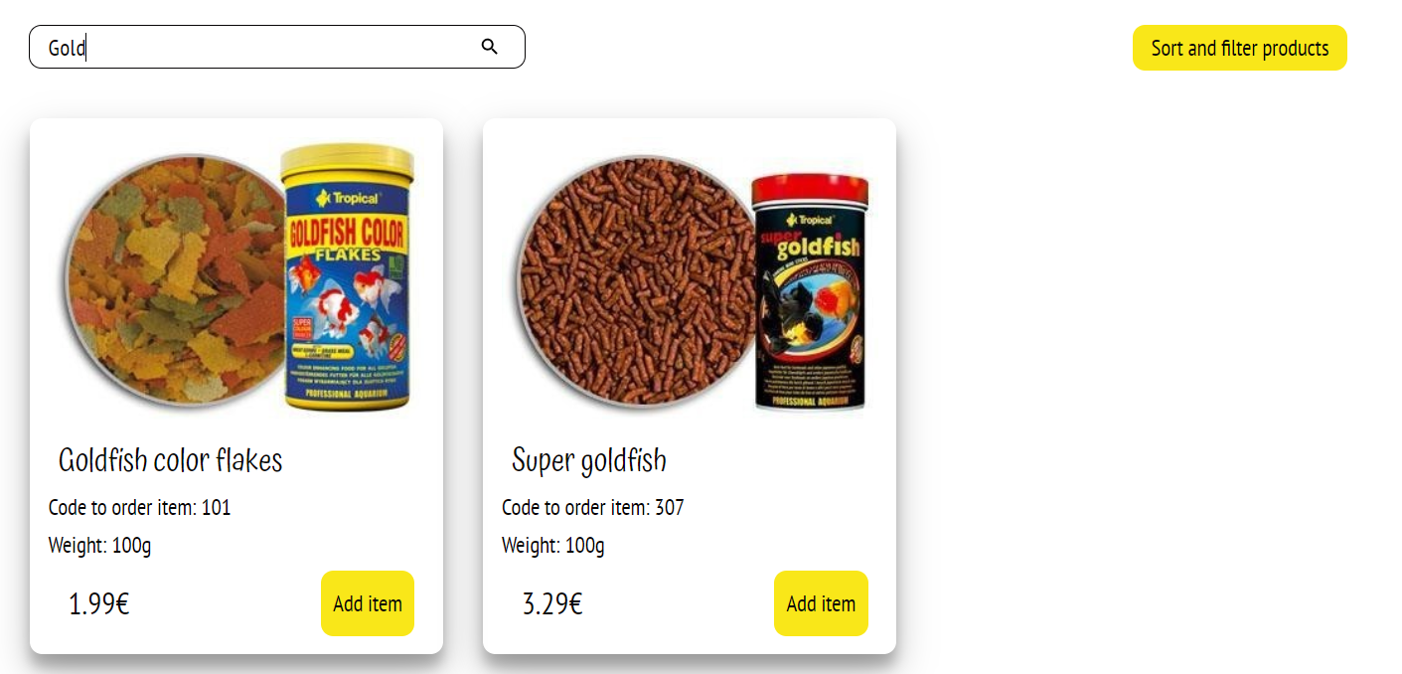

* Medju proizvodima se nalaze proizvodi nove kolekcije istaknuti sa slajdera na pocetku, oni imaju bredz *new*

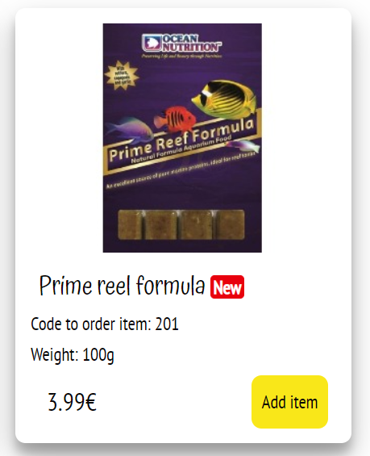

* I proizvodi koji su na popustu ovog meseca

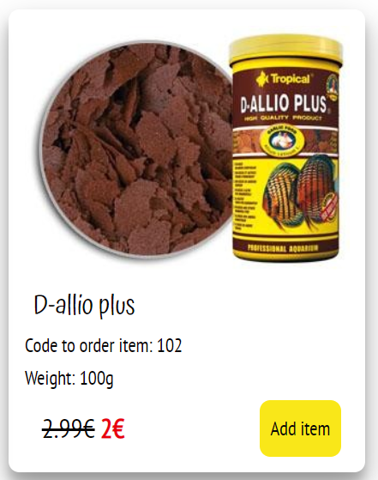

* Kontakt forma pomocu koje se porucuje hrana. Forma je validirana pomocu JS i regularnih izraza.

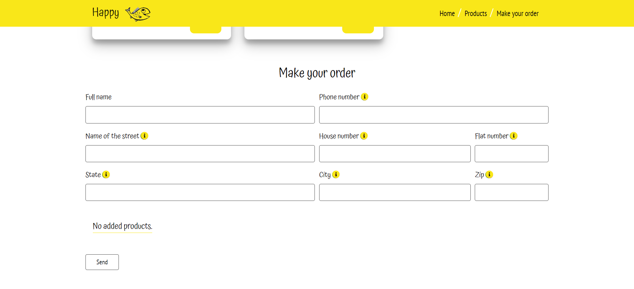

* Za polja koja treba da imaju dodatna objasnjenja, nalaze se stilizovane ikonice koje prikazuju poruku na hover.



* Ukoliko neko od polja nije ispravno popunjeno, njihova bordura ce dobiti crvenu boju. Pri ispravnom unosu, boja ce se ukloniti.

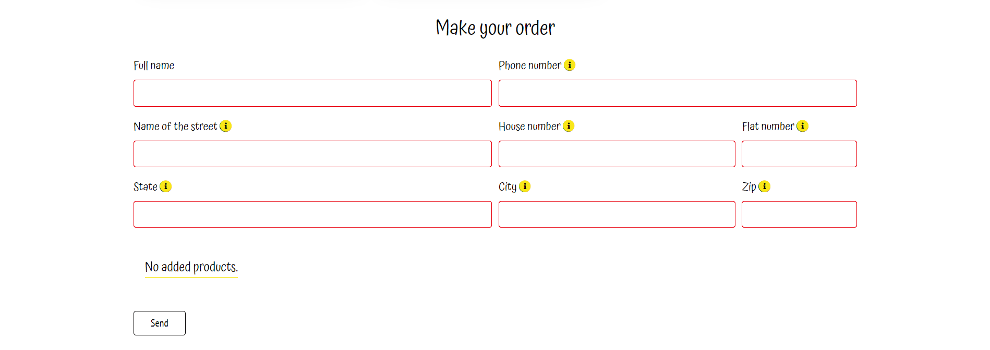

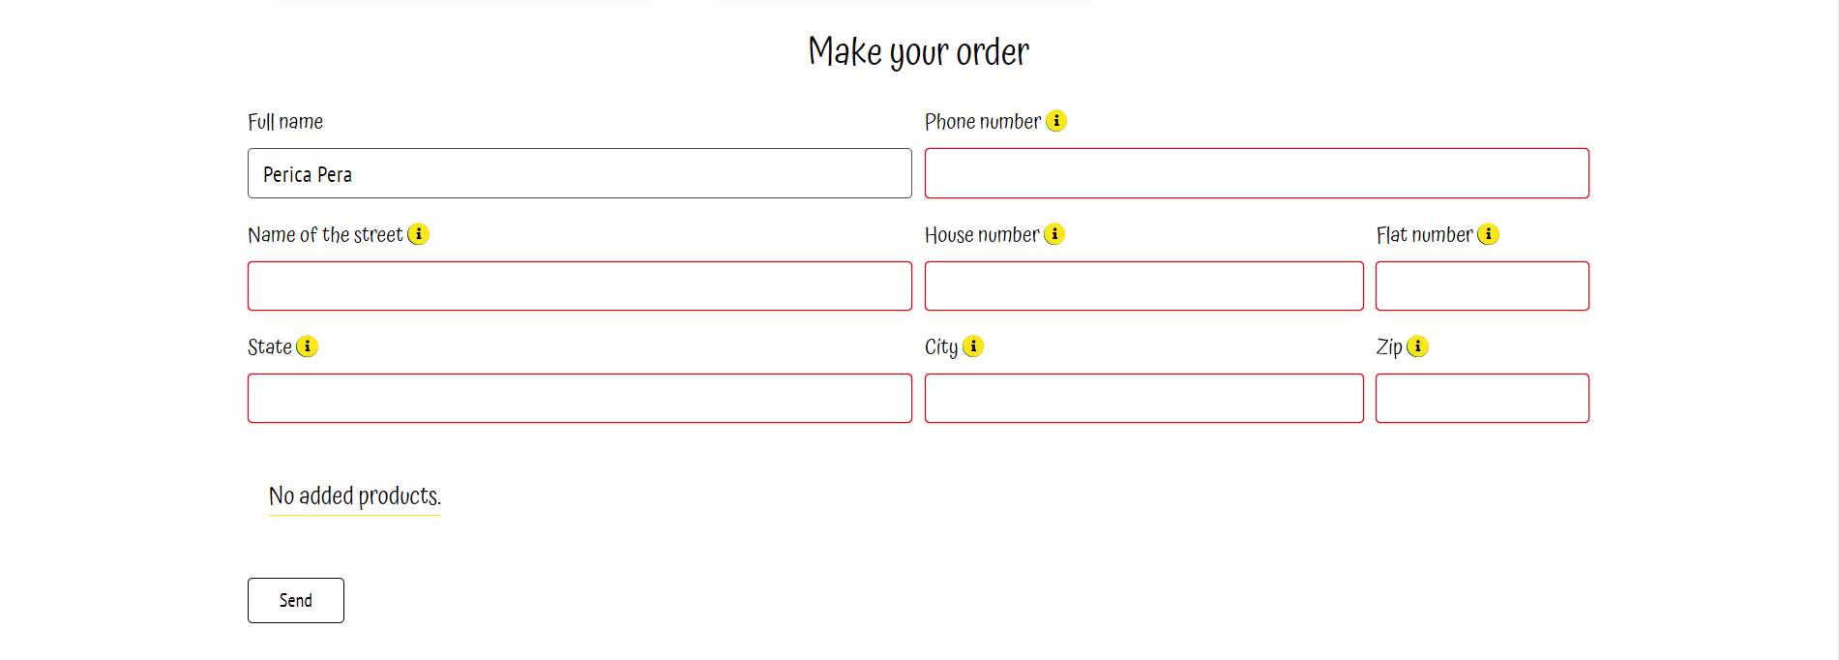

* Ukoliko su sva polja ispravno popunjena, otvorice se modal

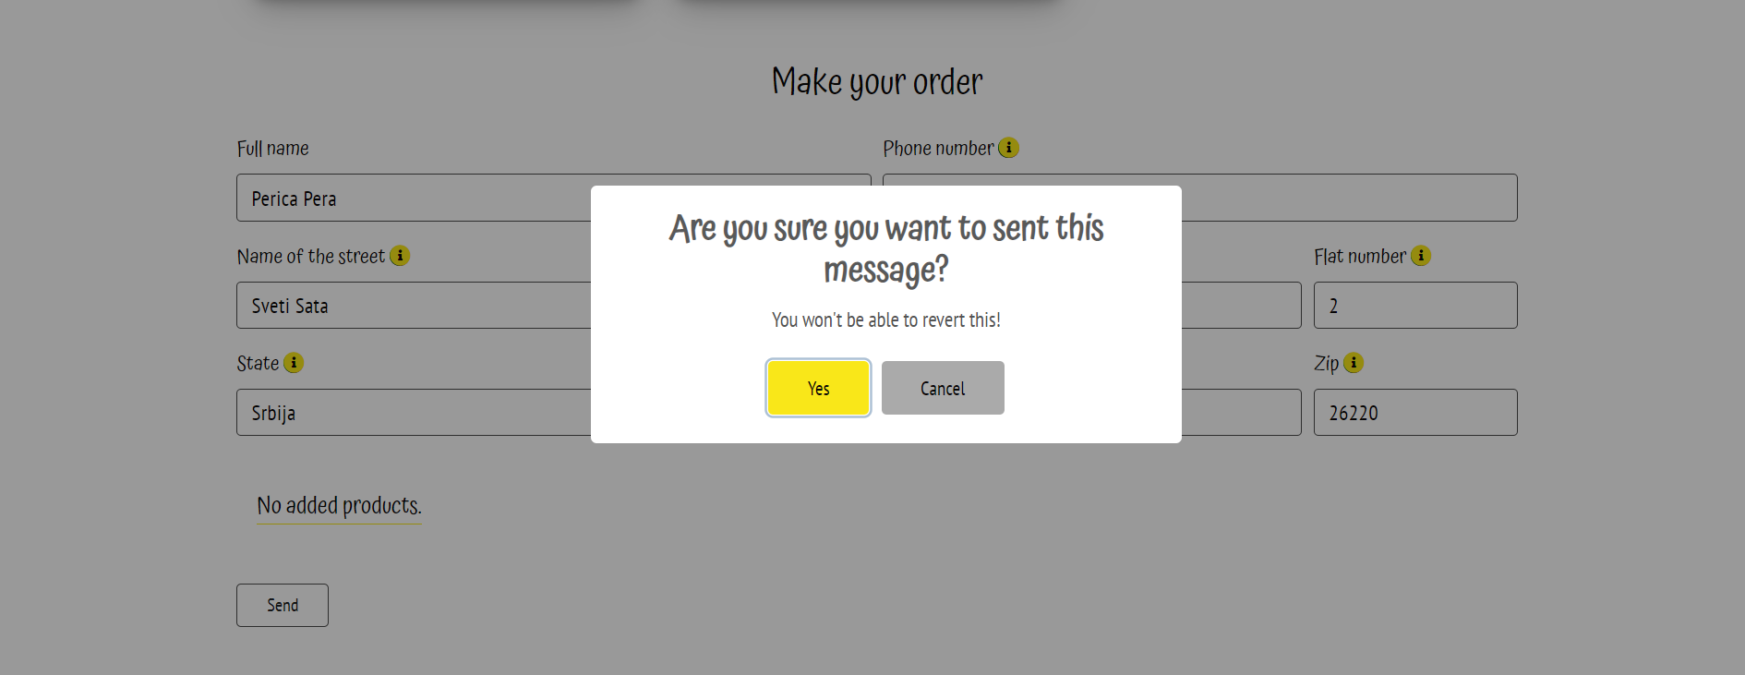

* Klikom na cancel, podaci ce ostati i biti moguci za izmenu
* Klikom na OK, izaci ce modal obavestenja o uspesno poslatoj poruci i polja forme ce se isprazniti.

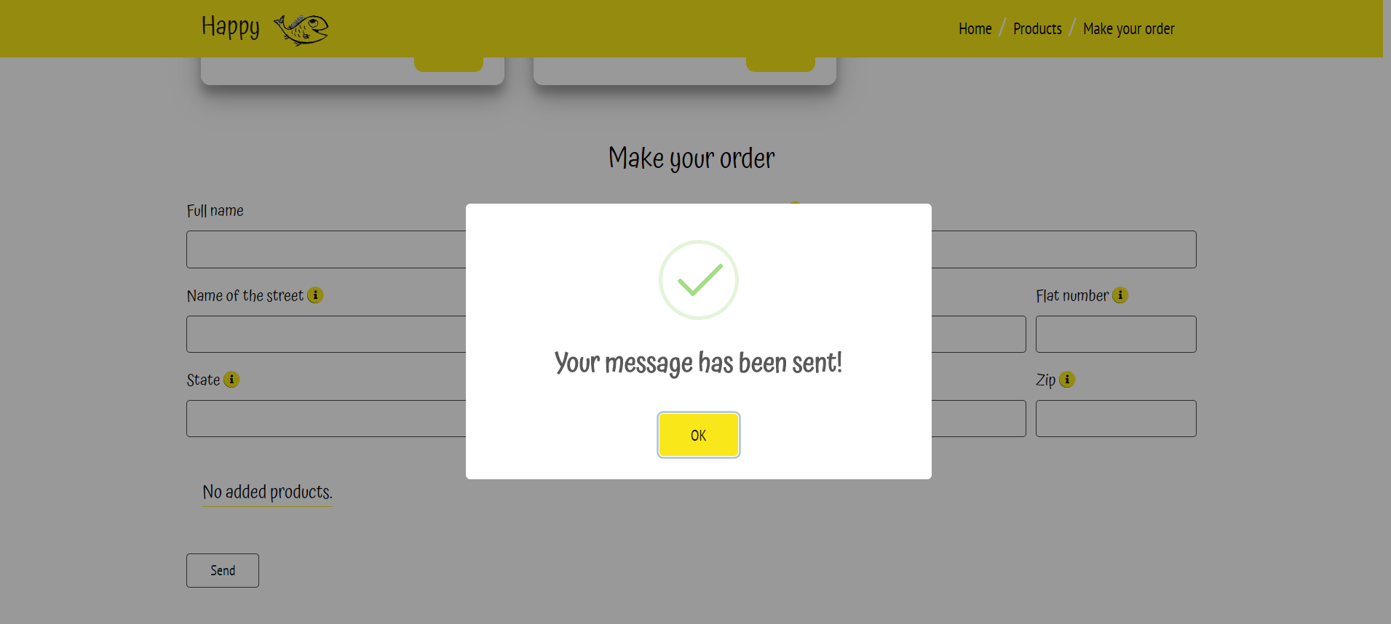

* Klikom na Add item ce se promeniti vrednost izrabranog proizvoda u Added

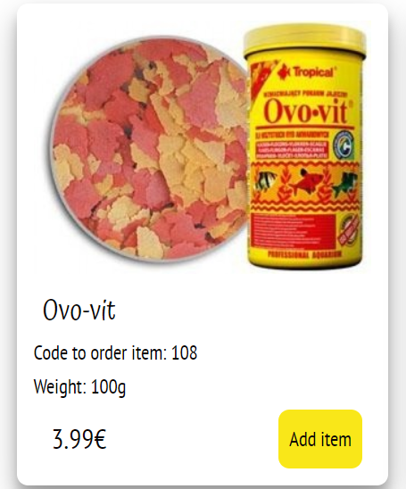

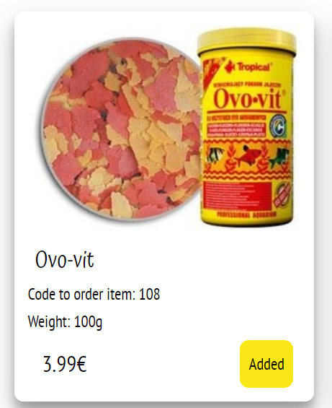

* Takodje, izabrani proizvod ce se pojaviti odmah ispod kontakt forme

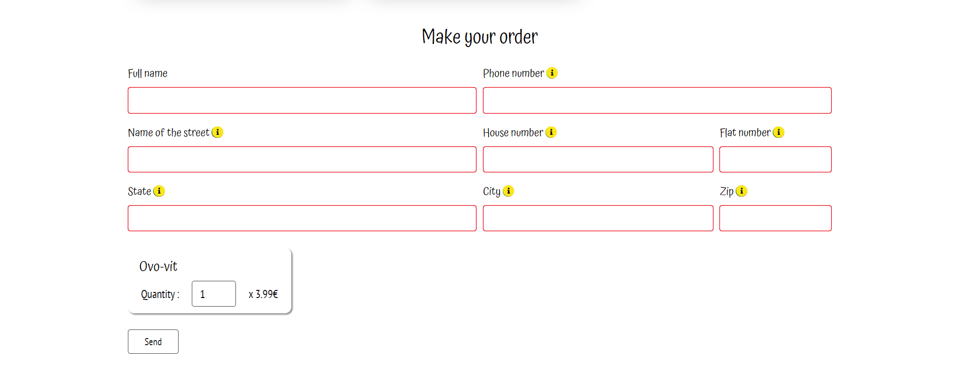

* Inicijalna kolicina je postavljena na 1, brojevi ne mogu biti negativni. Prikazana je i trenutna cena i ime izabranog proizvoda. Ukoliko je proizvod na akciji, bice prikazana akcijska cena

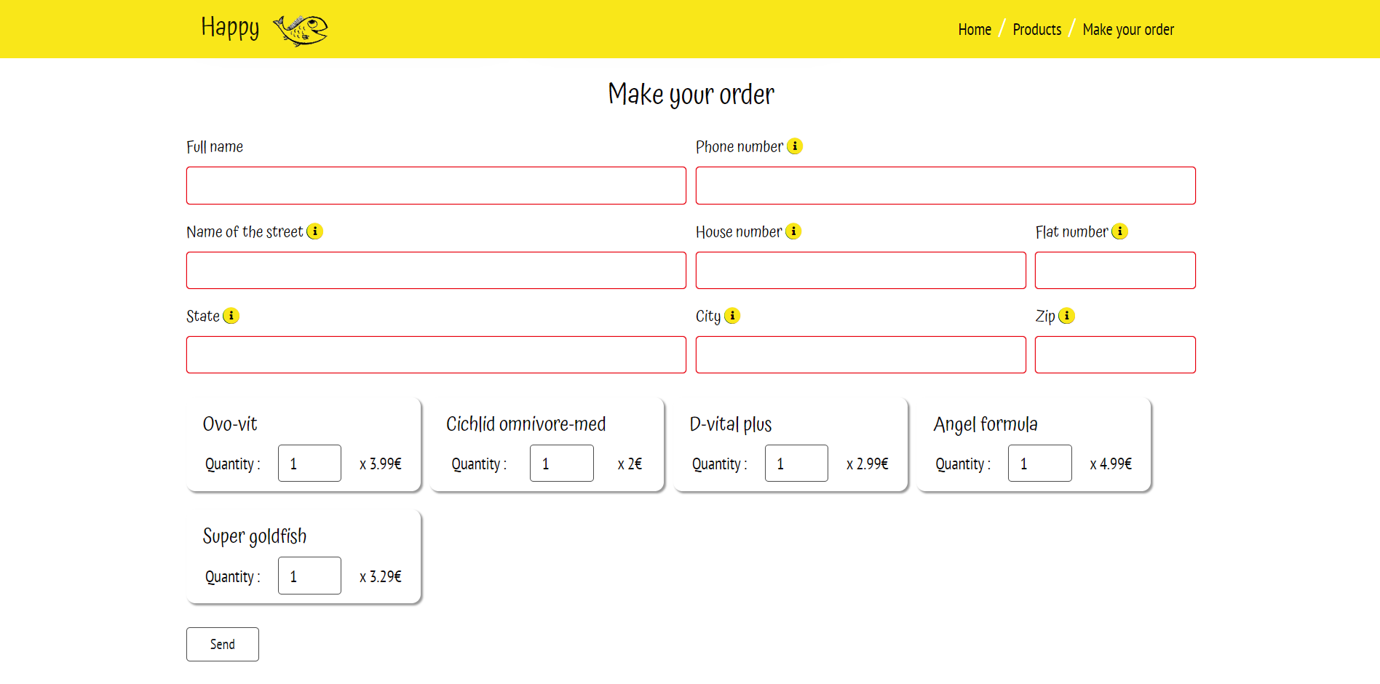

* Nije moguce obrisati odredjeni proizvod, ali je ostavljena mogucnost da se izabere 0 za kolicinu umesto toga.
* Dok nema izabranih proizvoda, bice prikazana poruka o tome

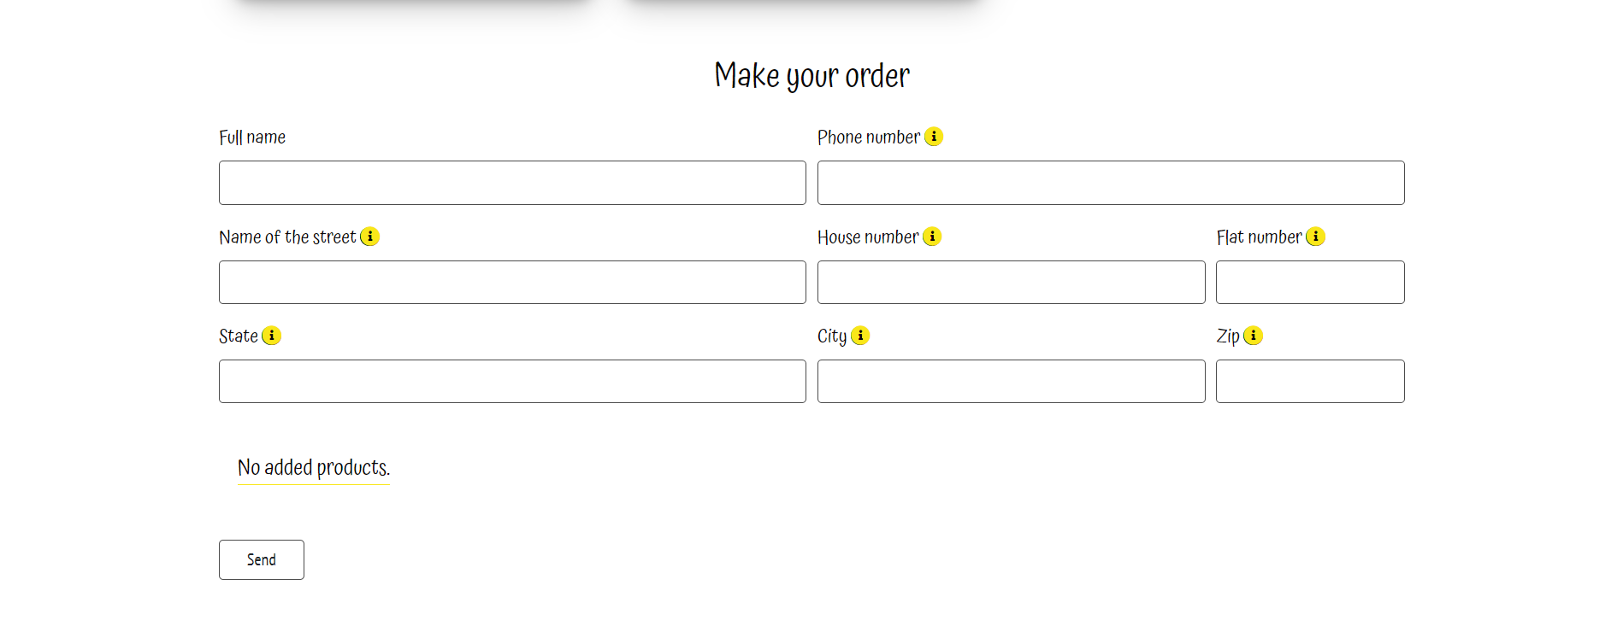

* Kao sto se prilikom slanja poruke brisu popunjena polja, obrisace se i ispod izabrani proizvodi. Opet ce biti vidljiva pokuka da nema proizvoda koji su izabrani
* Futer sadrzi link do dokumentacije, autora (modal iz sweet alerta sa dodatnim informacijama) i drustvenih mreza koje su dinamicki ispisane pomocu JS. Tu je i broj telefona koji se moze pozvati za vise informacija



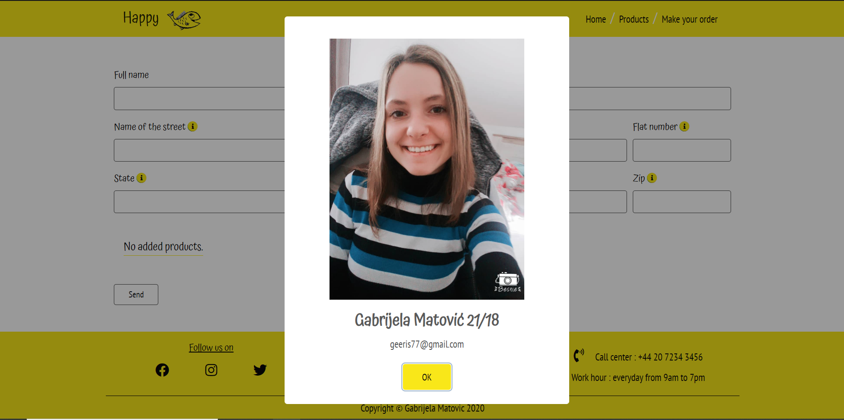

1. ROBOTS

User-agent:*

Disallow:/admin/

KODOVI

1. **HTML**

<!DOCTYPE html>

<html lang="en">

<head>

<!--Meta-->

<meta charset="UTF-8" />

<meta name="viewport" content="width=device-width, initial-scale=1.0" />

<meta name="keywords" content="fish,happy fish, food, flakes, pellets, frozen food, food for fish, fish shop, online fish shop, tropical food, ocean nutrition food" />

<meta name="description" content="Happy fish is is online shop for fish food. We have food of most famous brands such as Tropical and Ocean Nutrition." />

<!--Google fonts-->

<link href="https://fonts.googleapis.com/css?family=Atma&display=swap" rel="stylesheet" />

<link href="https://fonts.googleapis.com/css?family=Atma|PT+Sans+Narrow&display=swap" rel="stylesheet" />

<!--Font awesome-->

<link rel="stylesheet" href="https://use.fontawesome.com/releases/v5.8.2/css/all.css" />

<!--Files-->

<link rel="shortcut icon" href="assets/images/favico.ico" />

<link href="assets/css/bootstrap.min.css" type="text/css" rel="stylesheet" />

<link href="assets/css/style.css" type="text/css" rel="stylesheet" />

<title>Happy Fish</title>

</head>

<body>

<div class="container-fluid menu sticky-top">

<div class="container">

<div class="row">

<div class="col-lg-12">

<nav class="navbar navbar-expand-lg navbar-light">

<a class="navbar-brand p-0 swing" href="index.html">

<h1 class="m-0 highlight"> Happy <img src="assets/images/logo.png" class="slikaLogo backgroundMenu" alt="Logo" /></h1>

</a>

<button class="navbar-toggler" type="button" data-toggle="collapse" data-target="#navbarNavDropdown"

aria-controls="navbarNavDropdown" aria-expanded="false" aria-label="Toggle navigation">

<span class="navbar-toggler-icon"></span>

</button>

<div class="collapse navbar-collapse flex-row-reverse" id="navbarNavDropdown">

<ul class="navbar-nav">

<li class="nav-item">

<a class="nav-link" href="#">Home</a>

</li>

<span class="menuLine"> &#47; </span>

<li class="nav-item">

<a class="nav-link" href="#ourProducts">Products</a>

</li>

<span class="menuLine"> &#47; </span>

<li class="nav-item">

<a class="nav-link" href="#order">Make your order</a>

</li>

</ul>

</div>

</nav>

</div>

</div>

</div>

</div>

<div class="container-fluid menu pb-3">

<div class="container" id="headerImages">

<div class="row">

<div class="col-sm-12">

</div>

</div>

</div>

</div>

<div class="container">

<div class="row">

<div class="col-lg-12">

<ul class="d-flex justify-content-md-around p-0 mt-5 mb-4 flex-lg-row promena487">

<li class="text-center m-3">

<i class="fas fa-thumbs-up propI"></i>

<p class="p-2">Free shipping</p>

</li>

<li class="text-center m-3">

<i class="fas fa-dolly propI"></i>

<p class="p-2">Delivery throughout whole europe</p>

</li>

<li class="text-center m-3">

<i class="fas fa-coins propI"></i>

<p class="p-2">Best prices</p>

</li>

</ul>

</div>

</div>

</div>

<div class="container">

<div class="row mb-5">

<div class="col-lg-12 pl-4 pr-4">

<h2 class="mb-3 highlight"> About our food </h2>

<h3 class="food mt-4 highlight"> Flake food </h3>

<p> Flake Food is the most common of all fish foods and is generally the easiest to use. A variety of flakes are available for specific fish. The ingredients within each flake were chosen based on

the natural diet of each type of fish. A flake food is a great basic staple food for all fish, each according to its

type.

</p>

<h3 class="food mt-4 highlight"> Pellets </h3>

<p>

Pellets come in a variety of sizes but most are for larger fish. Cichlid pellets are common, as well as pellets for

larger predatory fish like catfish or sharks. Pellets contain the same basic ingredients as flake foods, just in a

different form. Some pellets are designed to float, while others will slowly sink to feed bottom-dwellers.

</p>

<h3 class="food mt-4 highlight"> Frozen food </h3>

<p>

Like freeze-dried food, frozen food is in its natural form, with varieties ranging from brine shrimp, krill,

mysis, and other basics, to nutritious specialty blends created for specific fish, like Discus formula or Shark formula.

</p>

</div>

</div>

</div>

<div class="container" id="ourProducts">

<div class="row">

<div class="col-md-7 col-sm-12 justify-content-start mb-4">

<input class="search form-control" id="search" type="text" placeholder="Search">

</div>

<div class="col-md-5 col-sm-12 justify-content-md-end justify-content-sm-start d-flex pr-md-5 p-sm-0">

<div id="mySidenav" class="sidenav">

<div class="headerSide">

<a class="navbar-brand p-0 swing closebtn" href="index.html">

<h1 class="m-0 highlight"> Happy <img src="assets/images/logo.png" class="slikaLogo backgroundMenu" alt="Logo" />

</h1>

</a>

<a href="javascript:void(0)" class="closebtn" onclick="closeNav()">&times;</a>

</div>

<div class="mt-4">

<span class="forfilters d-flex highlight"> Sort products by : </span>

<select class="custom-select" id="selectPrice">

<option selected value="0"> Recomended </option>

<option value="1">Price : lowest to highest</option>

<option value="2">Price : highest to lowest</option>

<!-- <option value="3">Three</option> -->

</select>

</div>

<div class="mt-4">

<span class="forfilters d-flex highlight"> Type of food </span>

<div class="d-flex flex-column" id="typeOfFood">

</div>

</div>

<div class="mt-4">

<span class="forfilters d-flex highlight"> Manufacturer </span>

<div class="d-flex flex-column" id="brand">

</div>

</div>

<div class="mt-4">

<a href="#" class="reset"> Reset filters </a>

</div>

</div>

<!-- Use any element to open the sidenav -->

<span onclick="openNav()" class="sortAndFilter">Sort and filter products</span>

</div>

</div>

<!-- <div class="row forp575">

<div class="col-lg-5 col-md-6 col-sm-1 mt-2 mb-4 p575 d-block mx-auto">

<span class="forfilters d-flex justify-content-around"> Type of food </span>

<div class="d-flex flex-row keepMyFilters" id="typeOfFood">

</div>

</div>

<div class="col-lg-2 mt-2 mb-4 col-sm-12 d-flex justify-content-center align-items-center">

<a href="#" class="reset" id="reset"> Reset filters </a>

</div>

<div class="col-lg-5 p575 col-md-6 mt-2 col-sm-12 mb-4">

<span class="forfilters d-flex justify-content-around"> Manufacturer </span>

<div class="d-flex flex-row keepMyFilters" id="brand">

</div>

</div>

</div> -->

</div>

<div class="container">

<div class="col-lg-12">

<div class="row flex-wrap just d-flex " id="products">

<!-- <div class="borderProducts m-1">

<img src="assets/images/item.jpg" class="text-center" alt="nesto" />

<h2 class="highlight ml-2 mt-1"> D allio plus </h2>

<p class="mb-1">Code to order item:<span class="code"> 67876</span></p>

<p class="mb-2">Weight: <span class="code">10gr</span> </p>

<p class="mb-2"> Complete food for fish and</p>

<div class="d-flex justify-content-between align-content-center">

<span class="p-2 ml-2 cena">20$</span>

<a href="#" class="add text-center mr-2"> Add item </a>

</div>

</div> -->

</div>

</div>

</div>

<!--FORM-->

<div class="container" id="order">

<div class="row">

<div class="col-lg-12">

<h2 class="highlight text-center mt-3 mb-4"> Make your order </h2>

</div>

</div>

<div class="row">

<div class="col-lg-12">

<form method="POST" action="" id="forma">

<div class="form-row">

<div class="form-group col-md-6 col-sm-6">

<label for="fullName" class="highlight">Full name

</label>

<input type="text" class="form-control" id="fullName" />

<span> </span>

</div>

<div class="form-group col-md-6 col-sm-6">

<label for="phone" class="highlight">Phone number

<i class="fas fa-info-circle" title="Number must start with + and have between 11 and 14 digits." data-toggle="tooltip" data-placement="bottom"></i>

</label>

<input type="text" class="form-control" id="phone" />

<span></span>

</div>

</div>

<div class="form-row">

<div class="form-group col-md-6">

<label for="streetName" class="highlight">

Name of the street

<i class="fas fa-info-circle" title="Street name must be full name of your street without abbrevations." data-toggle="tooltip" data-placement="bottom"></i>

</label>

<input type="text" class="form-control" id="streetName" />

<span> </span>

</div>

<div class="form-group col-md-4 col-sm-6">

<label for="house" class="highlight">

House number

<i class="fas fa-info-circle" title="House number must be between 1 and 5 digits." data-toggle="tooltip" data-placement="bottom"></i>

</label>

<input type="text" class="form-control" id="house" />

<span> </span>

</div>

<div class="form-group col-md-2 col-sm-6">

<label for="flat" class="highlight">

Flat number

<i class="fas fa-info-circle" title="Flat number must be between 1 and 3 digits." data-toggle="tooltip" data-placement="bottom"></i>

</label>

<input type="text" class="form-control" id="flat" />

<span> </span>

</div>

</div>

<div class="form-row">

<div class="form-group col-md-6">

<label for="state" class="highlight">

State

<i class="fas fa-info-circle" title="Name of state must be full name of your state without abbrevations." data-toggle="tooltip" data-placement="bottom"></i>

</label>

<input type="text" class="form-control" id="state" />

<span> </span>

</div>

<div class="form-group col-md-4 col-sm-6">

<label for="city" class="highlight">

City

<i class="fas fa-info-circle" title="Name of city must be full name of your city/countryside." data-toggle="tooltip" data-placement="bottom"></i>

</label>

<input type="text" class="form-control" id="city" />

<span> </span>

</div>

<div class="form-group col-md-2 col-sm-6">

<label for="zipCode" class="highlight">

Zip

<i class="fas fa-info-circle" title="Zip code must be between 4 and 5 digits." data-toggle="tooltip" data-placement="bottom"></i>

</label>

<input type="text" class="form-control" id="zipCode" />

<span> </span>

</div>

</div>

<div class="form-row" id="addedProducts">

</div>

<button class="btn dugme mt-3" id="check" >Send</button>

</form>

</div>

</div>

</div>

<div class="container-fluid zuto">

<div class="container pt-3 mt-5">

<div class="row">

<div class="col-lg-4 col-md-6 col-sm-12 text-sm-center">

<p class="m-0 highlight futer575 underline"> Follow us on</p>

<ul class="d-flex flex-row p-0 justify-content-around" id="socials">

<!-- <li> <a href="https://www.facebook.com/" target="_blank"> <i class="fab fa-facebook networksI ml-5"></i> </a></li>

<li> <a href="https://www.instagram.com/" target="_blank"> <i class="fab fa-instagram networksI"></i> </a></li>

<li> <a href="https://twitter.com/" target="_blank"> <i class="fab fa-twitter-square networksI mr-5"></i> </a> </li> -->

</ul>

</div>

<div class="col-lg-4 col-md-6 col-sm-12 text-sm-center">

<p class="m-0 highlight futer575 underline pt-1"> Useful links </p>

<ul class="d-flex flex-column p-0">

<li> <a href="#" target="_blank" class="futer575" id="author"> Author </i> </a></li>

<li> <a href="dokumentacija.pdf" target="_blank" class="futer575"> Documentation </i> </a></li>

</ul>

</div>

<div class="col-lg-4 text-sm-center p498">

<p class="padding575 m-0"><i class="fas fa-phone-volume networksI specific"></i> Call center : <span class="hoverEff"> +44 20 7234 3456 </span> </p>

<p class="ml-3 padding575"> Work hour : <span class="hoverEff"> everyday from 9am to 7pm </span></p>

</div>

</div>

<div class="row copyright">

<div class="col-lg-12 text-center">

<p class="mt-2 mb-2">Copyright © Gabrijela Matovic 2020</p>

</div>

</div>

</div>

</div>

<div id="bodyOverlay" style="display: block;opacity: 1;"></div>

<!-- Sweet alert -->

<script src="https://cdn.jsdelivr.net/npm/sweetalert2@9"></script>

<script type="text/javascript" src="assets/js/jquery-3.4.1.min.js"></script>

<script type="text/javascript" src="assets/js/bootstrap.min.js"></script>

<script type="text/javascript" src="assets/js/main.js"></script>

</body>

</html>

1. **CSS**

html {

scroll-behavior: smooth; }

body {

font-family: "PT Sans Narrow", sans-serif;

font-size: 18px;

color: #080607; }

a {

text-decoration: none;

color: #080607; }

a:hover {

text-decoration: none;

color: #080607; }

ul {

list-style-type: none; }

.underline {

text-decoration: underline; }

.highlight {

font-family: "Atma", cursive; }

.saleSlika {

width: 100%; }

/*MENU*/

.sticky-top {

z-index: 100 !important; }

.menu {

border-bottom: 1px solid #080607;

background-color: #fff; }

.menu:first-child {

background-color: #F9E719;

border: inherit;

margin-bottom: 20px; }

#slika {

width: 100%;

height: auto; }

h1 {

font-size: 27px;

width: 100px; }

.slikaLogo {

width: 80%; }

.swing:hover h1 img {

animation: swing 1s; }

@-webkit-keyframes swing {

20% {

-webkit-transform: rotate3d(0, 0, 1, 15deg);

transform: rotate3d(0, 0, 1, 15deg); }

40% {

-webkit-transform: rotate3d(0, 0, 1, -10deg);

transform: rotate3d(0, 0, 1, -10deg); }

60% {

-webkit-transform: rotate3d(0, 0, 1, 5deg);

transform: rotate3d(0, 0, 1, 5deg); }

80% {

-webkit-transform: rotate3d(0, 0, 1, -5deg);

transform: rotate3d(0, 0, 1, -5deg); }

to {

-webkit-transform: rotate3d(0, 0, 1, 0deg);

transform: rotate3d(0, 0, 1, 0deg); } }

.backgroundMenu {

background-color: #F9E719;

border-radius: 30px; }

.menuLine {

color: #fff;

font-size: 25px; }

/*END MENU*/

/*FILTERS*/

.selectpicker {

border-radius: 10px;

border: 1px solid #080607;

width: 200px;

height: fit-content;

padding: 5px 15px; }

.sortAndFilter {

cursor: pointer;

padding: 5px 15px;

background-color: #F9E719;

height: fit-content;

border-radius: 10px; }

.custom-select {

color: #080607;

border: none;

border-top: 1px solid #080607;

border-bottom: 1px solid #080607;

font-size: 18px;

padding: 10px;

border-radius: 10px;

height: fit-content !important;

cursor: pointer; }

.custom-select option {

background-color: #fff; }

.reset {

background-color: #F9E719;

border: 1px solid #F9E719;

display: block;

width: 100%;

text-align: center;

padding: 10px 0px;

margin-top: 40px !important; }

.filters {

border-top: 1px solid #080607;

padding: 10px;

width: 100% !important; }

.filters:first-child {

border-radius: 10px 10px 0px 0px; }

.filters:last-child {

border-bottom: 1px solid #080607;

border-radius: 0px 0px 10px 10px; }

.forfilters {

padding: 10px 7px;

width: 100% !important;

margin: 0 auto;

font-size: 19px; }

/*END FILTERS*/

/*CONTENT*/

.notFound {

font-family: "Atma", cursive;

font-size: 20px;

border-bottom: 1px solid #F9E719;

margin: 30px 0px 35px 2%; }

.notFound p {

margin-bottom: 0px;

text-align: center;

width: 100%; }

.fa-check-circle {

position: absolute;

top: 30%;

left: 90%;

background-color: #080607;

color: #F9E719;

border-radius: 20px; }

.disappear {

display: none; }

.brand, .food {

position: relative; }

.productMenu li:hover {

margin-left: 5px; }

.borderProducts {

box-shadow: 0 14px 28px rgba(0, 0, 0, 0.25), 0 10px 10px rgba(0, 0, 0, 0.22);

border-radius: 10px;

width: 30% !important;

padding: 15px;

height: fit-content; }

.borderProducts img {

width: 100%; }

.add {

width: fit-content;

padding: 13px 10px 0px 10px;

background-color: #F9E719;

border-radius: 10px; }

.cena {

font-size: 25px; }

.sale {

text-decoration: line-through; }

.saleRed {

color: #E8000D;

font-weight: bold; }

.badge {

border: 1px solid #E8000D;

background-color: #E8000D;

color: #fff;

padding: 2px;

font-family: "PT Sans Narrow", sans-serif; }

h3 {

font-size: 24px; }

h2 {

font-size: 30px; }

.code {

font-size: 18px; }

/*END CONTENT*/

/*PROPERTIES*/

.propI {

font-size: 35px;

background-color: #F9E719;

padding: 35px;

border-radius: 60px;

color: #080607; }

.propI:hover {

animation: jello 1s; }

/*Animate css*/

@-webkit-keyframes jello {

from,

11.1%,

to {

-webkit-transform: translate3d(0, 0, 0);

transform: translate3d(0, 0, 0); }

22.2% {

-webkit-transform: skewX(-12.5deg) skewY(-12.5deg);

transform: skewX(-12.5deg) skewY(-12.5deg); }

33.3% {

-webkit-transform: skewX(6.25deg) skewY(6.25deg);

transform: skewX(6.25deg) skewY(6.25deg); }

44.4% {

-webkit-transform: skewX(-3.125deg) skewY(-3.125deg);

transform: skewX(-3.125deg) skewY(-3.125deg); }

55.5% {

-webkit-transform: skewX(1.5625deg) skewY(1.5625deg);

transform: skewX(1.5625deg) skewY(1.5625deg); }

66.6% {

-webkit-transform: skewX(-0.78125deg) skewY(-0.78125deg);

transform: skewX(-0.78125deg) skewY(-0.78125deg); }

77.7% {

-webkit-transform: skewX(0.390625deg) skewY(0.390625deg);

transform: skewX(0.390625deg) skewY(0.390625deg); }

88.8% {

-webkit-transform: skewX(-0.1953125deg) skewY(-0.1953125deg);

transform: skewX(-0.1953125deg) skewY(-0.1953125deg); } }

/*END PROPERTIES*/

/*FORM*/

.redBorder {

border: 1px solid #E8000D !important;

box-shadow: 0px 0px 1px #E8000D; }

.redBorder:focus {

box-shadow: 0px 0px 1px #E8000D !important; }

.dugme {

width: 80px;

border-color: rgba(0, 0, 0, 0.7);

margin-top: 10px; }

.dugme:hover {

border: 1px solid #F9E719;

background-color: #F9E719; }

.form-control {

font-size: 18px;

letter-spacing: 0.5px;

color: #080607;

border-color: rgba(0, 0, 0, 0.7); }

.form-control:focus {

outline: none; }

.form-control::placeholder {

color: rgba(0, 0, 0, 0.7); }

.fa-info-circle {

color: #F9E719;

background-color: #080607;

border-radius: 20px; }

/*END FORM*/

/*FOOTER*/

.networksI {

padding: 8px;

background-color: #F9E719;

margin: 6px;

color: #080607;

font-size: 25px;

border-radius: 30px; }

.zuto {

background-color: #F9E719; }

.specific {

padding: 8px 10px; }

.copyright {

border-top: 1px solid #080607; }

.hoverEff:hover {

color: rgba(0, 0, 0, 0.9);

cursor: pointer;

text-decoration: underline; }

/*END FOOTER*/

/*Edited*/

.container-fluid {

padding: 0px; }

.navbar-light .navbar-nav .nav-link {

color: #080607; }

.navbar-light .navbar-nav .nav-link:focus, .navbar-light .navbar-nav .nav-link:hover {

color: #080607; }

.navbar-light .navbar-toggler {

border-color: #F9E719;

background-color: #F9E719; }

textarea:focus,

input[type="text"]:focus,

input[type="password"]:focus,

input[type="datetime"]:focus,

input[type="datetime-local"]:focus,

input[type="date"]:focus,

input[type="month"]:focus,

input[type="time"]:focus,

input[type="week"]:focus,

input[type="number"]:focus,

input[type="email"]:focus,

input[type="url"]:focus,

input[type="search"]:focus,

input[type="tel"]:focus,

input[type="color"]:focus,

.uneditable-input:focus, .btn:focus, .custom-select:focus {

border-color: inherit;

box-shadow: inherit;

outline: 0 none !important;

color: #080607; }

.form-control:disabled, .form-control[readonly] {

background-color: #fff; }

.form-control:disabled:focus, .form-control[readonly]:focus {

color: #080607; }

/*END EDITED*/

/*SEARCH*/

.search {

width: 400px;

padding: 5px 15px;

font-size: 18px;

height: 35px;

margin-left: 15px;

box-shadow: none;

background-color: transparent;

transition: transform 250ms ease-in-out;

line-height: 18px;

color: #080607;

background-color: transparent;

background-image: url("data:image/svg+xml;charset=utf8,%3Csvg xmlns='http://www.w3.org/2000/svg' width='24' height='24' viewBox='0 0 24 24'%3E%3Cpath d='M15.5 14h-.79l-.28-.27C15.41 12.59 16 11.11 16 9.5 16 5.91 13.09 3 9.5 3S3 5.91 3 9.5 5.91 16 9.5 16c1.61 0 3.09-.59 4.23-1.57l.27.28v.79l5 4.99L20.49 19l-4.99-5zm-6 0C7.01 14 5 11.99 5 9.5S7.01 5 9.5 5 14 7.01 14 9.5 11.99 14 9.5 14z'/%3E%3Cpath d='M0 0h24v24H0z' fill='none'/%3E%3C/svg%3E");

background-repeat: no-repeat;

background-size: 18px 18px;

background-position: 95% center;

border-radius: 10px;

border: 1px solid #080607; }

/*MEDIA*/

@media screen and (max-width: 487px) {

.promena487 {

flex-direction: column; } }

@media screen and (max-width: 1199px) {

.borderProducts {

width: 29.6% !important; } }

@media screen and (max-width: 991px) {

.borderProducts {

width: 45% !important; }

.productMenu {

flex-direction: row !important;

width: 100%; }

.menuLine {

display: none; } }

@media screen and (max-width: 767px) {

h1 {

font-size: 25px; }

h2 {

font-size: 25px; }

h3 {

font-size: 22px; }

.slikaLogo {

width: 70%; }

.borderProducts {

width: 70% !important;

margin-left: 15% !important; }

.productMenu {

width: 50%; }

.add {

height: 50px; }

.search {

width: 90%;

margin: 0 auto !important; }

.sortAndFilter {

margin: 0px 0px 10px 40px; }

.promena487 {

flex-direction: column; }

.sidenav .closebtn:first-child {

padding-top: 5px !important; } }

@media screen and (max-width: 575px) {

body {

font-size: 17px; }

.forfilters {

font-size: 17px; }

.propI {

padding: 25px;

font-size: 30px; }

.futer575 {

display: flex;

justify-content: center; }

.padding575 {

text-align: center;

width: 100%; }

.form-control {

width: 90%; }

.form-group {

margin: inherit auto !important;

margin-left: 10% !important; }

.dugme {

width: 30%;

margin-top: 20px;

margin-left: 10%; }

.sortAndFilter {

margin-left: 25px; } }

@media screen and (max-width: 498px) {

.p498 {

display: flex;

flex-direction: column;

justify-content: center; }

.p498 i {

display: none; }

.padding575 {

text-align: center;

margin: 0px !important; }

.padding575:last-child {

padding-bottom: 20px;

padding-top: 5px; }

.p498 {

padding-top: 10px; }

.sortAndFilter {

margin: 0 auto 10px auto; } }

@media screen and (max-width: 335px) {

.add {

padding: 5px;

height: 40px;

margin-top: 5px; }

.cena {

font-size: 22px; }

h3 {

font-size: 22px; }

h1 {

font-size: 20px; }

.slikaLogo {

width: 60%; }

.navbar-light .navbar-toggler {

padding: 3px 7px; }

.sidenav .closebtn:first-child {

padding-top: 8px !important; } }

/*MEDIA END*/

.sidenav-overlay {

position: fixed;

top: 0;

left: 0;

right: 0;

opacity: 0;

height: 120vh;

background-color: rgba(0, 0, 0, 0.4);

z-index: 101;

display: none; }

.sidebar {

overflow: hidden; }

.sidenav {

height: 100%;

/* 100% Full-height */

width: 0;

/* 0 width - change this with JavaScript */

position: fixed;

/* Stay in place */

z-index: 102;

/* Stay on top */

top: 0;

/* Stay at the top */

left: 0;

background-color: #fff;

/* Black*/

overflow-x: hidden;

/* Disable horizontal scroll */

padding-top: 60px;

/* Place content 60px from the top */

transition: 0.5s;

/* 0.5 second transition effect to slide in the sidenav */ }

.headerSide {

border-bottom: 1px solid #080607;

padding-bottom: 10px; }

/* Position and style the close button (top right corner) */

.sidenav .closebtn {

position: absolute;

top: 6px;

right: 25px;

font-size: 36px;

margin-left: 50px;

z-index: 5; }

.sidenav .closebtn:first-child {

top: 10px;

margin-right: 150px;

padding-top: 10px; }

/**SWEET ALERT*/

.swal2-styled.swal2-confirm {

background-color: #F9E719 !important;

color: #080607 !important; }

.swal2-styled.swal2-cancel {

border: 0;

border-radius: .25em;

background: initial;

background-color: #aaa;

color: #080607 !important;

font-size: 1.0625em; }

.swal2-title {

font-family: "Atma", cursive !important; }

.swal2-content, .swal2-styled.swal2-cancel, .swal2-styled.swal2-confirm {

font-family: "PT Sans Narrow", sans-serif !important; }

/* ADDED PRODUCTS */

.shop {

width: 23%;

box-shadow: 2px 2px 2px rgba(0, 0, 0, 0.4);

margin: 10px 5px;

padding: 10px;

border-radius: 10px; }

.shop h3 {

font-size: 22px; }

.number {

width: 70px !important; }

@media screen and (max-width: 991px) {

.shop {

width: 48.5%; } }

@media screen and (max-width: 767px) {

.shop {

width: 47.5%; } }

@media screen and (max-width: 575px) {

.shop {

width: 70%;

margin-left: 10%; }

#addedProducts {

margin-left: 8%; } }

@media screen and (max-width: 430px) {

.shop {

width: 90%;

margin-left: 0%; } }

@media screen and (max-width: 300px) {

.quantity {

display: none; } }

/*# sourceMappingURL=style.css.map */

1. **JS / JQuery**

window.onload = function(){

/*AUTOCOMPLETE*/

$('input').attr('autocomplete', 'off');

/* GET PRODUCTS */

(function () {

$.ajax({

url: "assets/data/products.json",

method: "get",

dataType: "json",

success: function (products) {

showProducts(products);

},

error: function (xhr, error, status) {

alert(status);

}

})

})();

/*TYPE OF FOOD AND MANUFACTURER*/

fillTypeOfFood();

fillManufacturer();

fillFooterSocials();

/*HEADER CONTENT */

headerImages();

/*EVENTS*/

document.getElementById("search").addEventListener("keyup", sortAndFilter);

let filters = document.querySelectorAll(".filters");

for(let f of filters)

f.addEventListener("click", sortAndFilter);

document.getElementById("selectPrice").addEventListener("change", sortAndFilter);

/* LOCAL STORAGE */

$("#search").keyup(function () {

localStorage.setItem("search", $("#search").val());

});

$(".food").click(function () {

localStorage.setItem("food", $(this).attr("data-food-type"));

});

$(".brand").click(function () {

localStorage.setItem("brand", $(this).attr("data-brand"));

});

$(".reset").click(function(e){

e.preventDefault();

localStorage.removeItem("food");

localStorage.removeItem("brand");

localStorage.removeItem("search");

localStorage.removeItem("sort");

document.getElementsByClassName("search")[0].value='';

$(".food").find("i").addClass("disappear");

$(".brand").find("i").addClass("disappear");

$("#selectPrice").val("0");

//getProductsRequest();

sortAndFilter();

});

onbeforeunload = localStorage.removeItem("food");

localStorage.removeItem("brand");

localStorage.removeItem("search");

localStorage.removeItem("sort");

localStorage.removeItem("addedProducts");

$("#selectPrice").change(function(){

localStorage.setItem("sort", $(this).val());

});

/* FORM CHECK */

document.getElementById("check").addEventListener("click", checkData);

$('#author').click(function(e){

e.preventDefault();

Swal.fire({

title: 'Gabrijela Matović 21/18',

text: 'geeris77@gmail.com',

imageUrl: 'assets/images/author.jpg',

imageWidth: 350,

imageHeight: 470,

imageAlt: 'Author'

})

});

/* ACTIVE FILTER ICON */

(function () {

$(".food").click(function (e) {

e.preventDefault();

$(".food").find("i").addClass("disappear");

$(this).find("i").removeClass("disappear");

});

$(".brand").click(function (e) {

e.preventDefault();

$(".brand").find("i").addClass("disappear");

$(this).find("i").removeClass("disappear");

});

})();

/* ADD PRODUCTS FUNCTION */

if (localStorage.getItem("addedProducts") === null)

{

document.getElementById("addedProducts").innerHTML = `<p class="notFound"> No added products. </p>`;

}

var addedProducts = [];

$('body').on('click', 'a.add', function (e) {

let that = this;

e.preventDefault();

localStorage.removeItem("addedProducts");

console.log(localStorage.getItem("addedProducts"));

let potential = $(this).data("id");

if(addedProducts.includes(potential)){}

else{

addedProducts.push(potential);

$(that).html("Added");

}

//console.log(addedProducts);

localStorage.setItem("addedProducts", JSON.stringify(addedProducts));

addProducts(addedProducts);

});

}

/************************************************* FUNCTIONS ************************************************/

/************************************************************************************************************/

function showProducts(products){

let productsToPreview = products;

let content = '';

for(let p of productsToPreview)

{

content += `

<div class="borderProducts m-3 mb-5">

<img src="${p.slika.src}" class="text-center mb-3" alt="${p.slika.alt}" />

<h3 class="highlight ml-2 mt-1 mb-2"> ${p.naziv} `;

if(p.isNew == 1)

content += `<span class="badge"> New</span>`;

content +=`

</h3>

<p class="mb-1">Code to order item:<span class="code"> ${p.code}</span></p>

<p class="mb-2">Weight: <span class="code">${p.width}g</span> </p>

<div class="d-flex justify-content-between align-content-center">

<span class="p-2 ml-2 cena">`;

if(p.newPrice == 0)

content += `${p.price}€`;

else

content += `<span class="sale">${p.price}€</span> <span class="saleRed">${p.newPrice}€</span>`;

content +=`</span>

<a href="#" data-id="${p.id}" class="add text-center mr-2" > Add item </a>

</div>

</div>

`;

}

document.getElementById("products").innerHTML = content;

}

/* TYPE OF FOOD AND MANUFACTURER */

var filterObject = function (id, naziv) {

this.id = id,

this.naziv = naziv

}

var typeOfFood = [new filterObject(1, "Flakes"), new filterObject(2, "Frozen food"), new filterObject(3, "Pellets")];

var brand = [new filterObject(1, "Ocean Nutrition"), new filterObject(2, "Tropical") ];

/*FOOTER*/

var footerSocial = [

{

"id" : 1,

"href": "https://www.facebook.com/",

"content": `<i class="fab fa-facebook networksI ml-5"></i>`

},

{

"id": 2,

"href": "https://www.instagram.com/",

"content": `<i class="fab fa-instagram networksI"></i>`

},

{

"id": 3,

"href": "https://twitter.com/",

"content": `<i class="fab fa-twitter - square networksI mr-5"></i>`

}

];

function fillTypeOfFood(){

let content = '';

for(let t of typeOfFood)

{

content += `

<a href="#" class="filters food" data-food-type="${t.naziv}"> ${t.naziv} <i class="fas fa-check-circle disappear"></i></a>

`;

}

document.getElementById("typeOfFood").innerHTML += content;

}

function fillManufacturer(){

let content = '';

for (let b of brand) {

content += `

<a href="#" class="filters brand" data-brand="${b.naziv}"> ${b.naziv} <i class="fas fa-check-circle disappear"></i></a>

`;

}

document.getElementById("brand").innerHTML += content;

}

function fillFooterSocials(){

let content = '';

for (let s of footerSocial) {

content += `

<li> <a href="${s.href}" target="_blank"> ${s.content} </a></li>

`;

}

document.getElementById("socials").innerHTML += content;

}

/* HEADER CONTENT */

var images = [

{

src: "sale1.jpg",

alt: "Sale",

},

{

src: "sale2.jpg",

alt: "New collection",

}

];

document.getElementById("headerImages").innerHTML = `<img src="assets/images/sale1.jpg" class="saleSlika" alt="Sale" />`;

function headerImages() {

let i = 1;

setInterval(function () {

document.getElementById("headerImages").innerHTML = `<img src="assets/images/${images[i].src}" class="saleSlika" alt="${images[i].alt}" />`;

if (i == images.length - 1) {

i = 0;

}

else

i++;

}, 3000);

}

/* EVENT'S FUNCTION */

function sortAndFilter(){

var sortedAndFilteredProducts = [];

$.ajax({

url: "assets/data/products.json",

method: "get",

dataType: "json",

success: function (products) {

sortedAndFilteredProducts = products;

sortedAndFilteredProducts = search(sortedAndFilteredProducts);

sortedAndFilteredProducts = filterProductsFood(sortedAndFilteredProducts);

sortedAndFilteredProducts = filterProductsBrand(sortedAndFilteredProducts);

sortedAndFilteredProducts = sortProducts(sortedAndFilteredProducts);

if(sortedAndFilteredProducts.length!=0)

showProducts(sortedAndFilteredProducts);

else

document.getElementById("products").innerHTML = `<div class="notFound"> <p> No products were found matching your selection. </p> </div>`;

},

error: function (xhr, error, status) {

alert(status);

}

})

}

function search(products){

let productsToSearch = products;

let searched = products;

let find = localStorage.getItem("search");

if (localStorage.getItem("search") === null)

return searched;

else

searched = productsToSearch.filter(x => x.naziv.toLowerCase().includes(find.toLowerCase()));

return searched;

}

function sortProducts(products){

let productsToSort = products;

let checked = document.getElementById("selectPrice").value;

if(checked == 1)

{

productsToSort.sort((a,b) => {

if ((a.newPrice == 0 ? a.price : a.newPrice) > (b.newPrice == 0 ? b.price : b.newPrice))

return 1;

if ((a.newPrice == 0 ? a.price : a.newPrice) < (b.newPrice == 0 ? b.price : b.newPrice))

return -1;

return 0;

});

return productsToSort;

}

if(checked == 2)

{

productsToSort.sort((a, b) => {

if ((a.newPrice == 0 ? a.price : a.newPrice) > (b.newPrice == 0 ? b.price : b.newPrice))

return -1;

if ((a.newPrice == 0 ? a.price : a.newPrice) < (b.newPrice == 0 ? b.price : b.newPrice))

return 1;

return 0;

});

return productsToSort;

}

if(checked == 0)

{

return productsToSort;

}

}

function filterProductsFood(products){

let productsToFilter = products;

let choosenTypeOfFood = localStorage.getItem("food");

let filtered = products;

if (localStorage.getItem("food") === null)

{

return filtered;

}

else

filtered = productsToFilter.filter(x => x.type.naziv == choosenTypeOfFood);

return filtered;

}

function filterProductsBrand(products){

let productsToFilter = products;

let choosenBrand = localStorage.getItem("brand");

let filtered = products;

if (localStorage.getItem("brand") === null) {

return filtered;

}

else

filtered = productsToFilter.filter(x => x.brand.naziv == choosenBrand);

return filtered;

}

/* FORM CHECK */

var correct;

function checkData(e){

e.preventDefault();

correct = true;

checkFullName();

checkPhoneNumber();

checkStreetName();

checkHouseNumber();

checkFlatNumber();

checkState();

checkCity();

checkZipCode();

console.log(correct);

if(correct)

{

Swal.fire({

title: 'Are you sure you want to sent this message?',

text: "You won't be able to revert this!",

//icon: 'warning',

showCancelButton: true,

confirmButtonColor: '#3085d6',

//cancelButtonColor: '#E8000D',

confirmButtonText: 'Yes'

}).then((result) => {

if (result.value) {

Swal.fire({

title: 'Your message has been sent!',

icon: 'success'

});

let inputs = document.getElementsByTagName("input");

for(let i of inputs)

i.value='';

document.getElementById("addedProducts").innerHTML = `<p class="notFound"> No added products. </p>`;

}

})

}

}

function checkFullName(){

let fullName = document.getElementById("fullName").value;

let id ="fullName";

let request = /^([A-Z][a-z]{2,}\s)+([A-Z][a-z]{1,})$/;

//let nextP = fullName.nextElementSibling;

console.log(correct);

checkMyTextBox(fullName, request, id);

}

function checkPhoneNumber() {

let phoneNumber = document.getElementById("phone").value;

let id ="phone";

let request = /^\+[1-9][0-9]{10,13}$/;

checkMyTextBox(phoneNumber, request, id);

}

function checkStreetName() {

let streetName = document.getElementById("streetName").value;

let id="streetName";

let request = /^([1-9]\s)?([A-Z][a-z]{1,}\s)?([A-Z][a-z]{1,})$/;

checkMyTextBox(streetName, request, id);

}

function checkHouseNumber() {

let houseNumber = document.getElementById("house").value;

let id = "house";

let request = /^([1-9])([0-9])?([0-9])?([0-9])?([0-9])?$/;

checkMyTextBox(houseNumber, request, id);

}

function checkFlatNumber() {

let flatNumber = document.getElementById("flat").value;

let id = "flat";

let request = /^([1-9])([0-9])?([0-9])?$/;

checkMyTextBox(flatNumber, request, id);

}

function checkState() {

let state = document.getElementById("state").value;

let id = "state";

let request = /^([A-Z][a-z]{3,}\s)?([A-Z][a-z]{2,})$/;

checkMyTextBox(state, request, id);

}

function checkCity() {

let city = document.getElementById("city").value;

let id = "city";

let request = /^([A-Z][a-z]{2,}\s)*([A-Z][a-z]{2,})$/;

checkMyTextBox(city, request, id);

}

function checkZipCode() {

let zipCode = document.getElementById("zipCode").value;

let id = "zipCode";

let request = /^[0-9]{4,5}$/;

checkMyTextBox(zipCode, request, id);

}

function checkMyTextBox(data, criteria, id)

{

if(!criteria.test(data))

{

document.getElementById(`${id}`).classList.add("redBorder");

correct = false;

}

else

document.getElementById(`${id}`).classList.remove("redBorder");

}

/*SIDE BAR FILTERS*/

function openNav() {

document.getElementById("mySidenav").style.width = "280px";

document.getElementById("bodyOverlay").classList.add("sidenav-overlay");

document.getElementsByTagName("body")[0].classList.add("sidebar");

}

/* Set the width of the side navigation to 0 */

function closeNav() {

document.getElementById("mySidenav").style.width = "0";

document.getElementById("bodyOverlay").classList.remove("sidenav-overlay");

document.getElementsByTagName("body")[0].classList.remove("sidebar");

}

function addProducts(addedProducts){

$.ajax({

url: "assets/data/products.json",

method: "get",

dataType: "json",

success: function (products) {

let productsForCode = [];

let takeCodeFromAddedProducts = addedProducts;

for (let one of products) {

let j=0;

while(j<takeCodeFromAddedProducts.length)

{

if(one.id == takeCodeFromAddedProducts[j])

productsForCode.push(one);

j++;

}

}

console.log(productsForCode);

let content = '';

for(let one of productsForCode)

{

content += `

<div class="shop">

<h3 class="highlight p-2 mb-0"> ${one.naziv} </h3>

<div class="row d-flex justify-content-around align-items-center">

<p class="m-0 ml-3 quantity"> Quantity : </p>

<input type="number" class="form-control number" min="0" value="1" />

<p class="m-0 mr-3"> x ${one.newPrice == 0 ? one.price : one.newPrice}€ </p>

</div>

</div>

`;

}

document.getElementById("addedProducts").innerHTML = content;

},

error: function (xhr, error, status) {

alert(status);

}

});

}

$(function () {

$('.example-popover').popover({

container: 'body'

})

})

1. **JSON**

[

{

    "id" : 1,

    "slika" :

    {

    "src" : "assets/images/food/product1.jpg",

    "alt" : "Product1"

    },

    "naziv" : "Goldfish color flakes",

    "code" : 101,

    "width" : 100,

    "price" : 1.99,

    "newPrice" : 0,

    "brand" :

    {

    "id" : 2,

    "naziv" : "Tropical"

    },

    "type" :

    {

    "id": 1,

    "naziv": "Flakes"

    },

    "isNew" : 0

},

{

    "id": 2,

    "slika": {

        "src": "assets/images/food/product2.jpg",

        "alt": "Product2"

    },

    "naziv": "D-allio plus",

    "code": 102,

    "width": 100,

    "price": 2.99,

    "newPrice": 2,

    "brand":

    {

        "id": 2,

        "naziv": "Tropical"

    },

    "type":

    {

        "id": 1,

        "naziv": "Flakes"

    },

    "isNew": 0

},

{

    "id": 3,

    "slika": {

        "src": "assets/images/food/product3.jpg",

        "alt": "Product3"

    },

    "naziv": "Prime reel formula",

    "code": 201,

    "width": 100,

    "price": 3.99,

    "newPrice": 0,

    "brand":

    {

        "id": 1,

        "naziv": "Ocean Nutrition"

    },

    "type": {

        "id": 2,

        "naziv": "Frozen food"

    },

    "isNew": 1

},

{

    "id": 4,

    "slika": {

        "src": "assets/images/food/product4.jpg",

        "alt": "Product4"

    },

    "naziv": "Supervit",

    "code": 103,

    "width": 100,

    "price": 4.59,

    "newPrice": 0,

    "brand":

    {

        "id": 2,

        "naziv": "Tropical"

    },

    "type":

    {

        "id": 1,

        "naziv": "Flakes"

    },

    "isNew": 0

},

{

    "id": 5,

    "slika": {

        "src": "assets/images/food/product5.jpg",

        "alt": "Product5"

    },

    "naziv": "Cichlid color",

    "code": 104,

    "width": 100,

    "price": 3.59,

    "newPrice": 0,

    "brand":

    {

        "id": 2,

        "naziv": "Tropical"

    },

    "type":

    {

        "id": 1,

        "naziv": "Flakes"

    },

    "isNew": 0

},

{

    "id": 6,

    "slika": {

        "src": "assets/images/food/product6.jpg",

        "alt": "Product6"

    },

    "naziv": "Pygmy angel",

    "code": 202,

    "width": 100,

    "price": 3.99,

    "newPrice": 0,

    "brand":

    {

        "id": 1,

        "naziv": "Ocean Nutrition"

    },

    "type":

    {

        "id": 2,

        "naziv": "Frozen food"

    },

    "isNew": 1

},

{

    "id": 7,

    "slika": {

        "src": "assets/images/food/product7.jpg",

        "alt": "Product7"

    },

    "naziv": "Formula two",

    "code": 203,

    "width": 100,

    "price": 3.59,

    "newPrice": 0,

    "brand":

    {

        "id": 1,

        "naziv": "Ocean Nutrition"

    },

    "type":

    {

        "id": 2,

        "naziv": "Frozen food"

    },

    "isNew": 1

},

{

    "id": 8,

    "slika": {

        "src": "assets/images/food/product8.jpg",

        "alt": "Product8"

    },

    "naziv": "Pond sticks",

    "code": 301,

    "width": 100,

    "price": 4.99,

    "newPrice": 2,

    "brand":

    {

        "id": 2,

        "naziv": "Tropical"

    },

    "type":

    {

        "id": 3,

        "naziv": "Pellets"

    },

    "isNew": 0

},

{

    "id": 9,

    "slika": {

        "src": "assets/images/food/product9.jpg",

        "alt": "Product9"

    },

    "naziv": "Tropical",

    "code": 105,

    "width": 100,

    "price": 3.49,

    "newPrice": 0,

    "brand":

    {

        "id": 2,

        "naziv": "Tropical"

    },

    "type":

    {

        "id": 1,

        "naziv": "Flakes"

    },

    "isNew": 0

},

{

    "id": 10,

    "slika": {

        "src": "assets/images/food/product10.jpg",

        "alt": "Product10"

    },

    "naziv": "Shrimp sticks",

    "code": 302,

    "width": 100,

    "price": 3.99,

    "newPrice": 0,

    "brand":

    {

        "id": 2,

        "naziv": "Tropical"

    },

    "type":

    {

        "id": 3,

        "naziv": "Pellets"

    },

    "isNew": 0

},

{

    "id": 11,

    "slika": {

        "src": "assets/images/food/product11.jpg",

        "alt": "Product11"

    },

    "naziv": "Crusta sticks",

    "code": 303,

    "width": 100,

    "price": 2.99,

    "newPrice": 0,

    "brand":

    {

        "id": 2,

        "naziv": "Tropical"

    },

    "type":

    {

        "id": 3,

        "naziv": "Pellets"

    },

    "isNew": 0

},

{

    "id": 12,

    "slika": {

        "src": "assets/images/food/product12.jpg",

        "alt": "Product12"

    },

    "naziv": "Tubivit",

    "code": 106,

    "width": 100,

    "price": 2.49,

    "newPrice": 0,

    "brand":

    {

        "id": 2,

        "naziv": "Tropical"

    },

    "type":

    {

        "id": 1,

        "naziv": "Flakes"

    },

    "isNew": 0

},

{

    "id": 13,

    "slika": {

        "src": "assets/images/food/product13.jpg",

        "alt": "Product13"

    },

    "naziv": "Spirulina formula",

    "code": 204,

    "width": 100,

    "price": 2.79,

    "newPrice": 0,

    "brand":

    {

        "id": 1,

        "naziv": "Ocean Nutrition"

    },

    "type":

    {

        "id": 2,

        "naziv": "Frozen food"

    },

    "isNew": 1

},

{

    "id": 14,

    "slika": {

        "src": "assets/images/food/product14.jpg",

        "alt": "Product14"

    },

    "naziv": "Cichlid omnivore-small",

    "code": 304,

    "width": 100,

    "price": 1.99,

    "newPrice": 0,

    "brand":

    {

        "id": 2,

        "naziv": "Tropical"

    },

    "type":

    {

        "id": 3,

        "naziv": "Pellets"

    },

    "isNew": 0

},

{

    "id": 15,

    "slika": {

        "src": "assets/images/food/product15.jpg",

        "alt": "Product15"

    },

    "naziv": "Spirulina flakes",

    "code": 107,

    "width": 100,

    "price": 2.99,

    "newPrice": 0,

    "brand":

    {

        "id": 2,

        "naziv": "Tropical"

    },

    "type":

    {

        "id": 1,

        "naziv": "Flakes"

    },

    "isNew": 0

},

{

    "id": 16,

    "slika": {

        "src": "assets/images/food/product16.jpg",

        "alt": "Product16"

    },

    "naziv": "Bionautic",

    "code": 305,

    "width": 100,

    "price": 2.99,

    "newPrice": 0,

    "brand":

    {

        "id": 2,

        "naziv": "Tropical"

    },

    "type":

    {

        "id": 3,

        "naziv": "Pellets"

    },

    "isNew": 0

},

{

    "id": 17,

    "slika": {

        "src": "assets/images/food/product17.jpg",

        "alt": "Product17"

    },

    "naziv": "Formula one",

    "code": 205,

    "width": 100,

    "price": 3.59,

    "newPrice": 0,

    "brand":

    {

        "id": 1,

        "naziv": "Ocean Nutrition"

    },

    "type":

    {

        "id": 2,

        "naziv": "Frozen food"

    },

    "isNew": 1

},

{

    "id": 18,

    "slika": {

        "src": "assets/images/food/product18.jpg",

        "alt": "Product18"

    },

    "naziv": "Brine shrimp plus",

    "code": 206,

    "width": 100,

    "price": 2.99,

    "newPrice": 0,

    "brand":

    {

        "id": 1,

        "naziv": "Ocean Nutrition"

    },

    "type":

    {

        "id": 2,

        "naziv": "Frozen food"

    },

    "isNew": 1

},

{

    "id": 19,

    "slika": {

        "src": "assets/images/food/product19.jpg",

        "alt": "Product19"

    },

    "naziv": "Ovo-vit",

    "code": 108,

    "width": 100,

    "price": 3.99,

    "newPrice": 0,

    "brand":

    {

        "id": 2,

        "naziv": "Tropical"

    },

    "type":

    {

        "id": 1,

        "naziv": "Flakes"

    },

    "isNew": 0

},

{

    "id": 20,

    "slika": {

        "src": "assets/images/food/product20.jpg",

        "alt": "Product20"

    },

    "naziv": "Cichlid omnivore-med",

    "code": 306,

    "width": 100,

    "price": 3.39,

    "newPrice": 2,

    "brand":

    {

        "id": 2,

        "naziv": "Tropical"

    },

    "type":

    {

        "id": 3,

        "naziv": "Pellets"

    },

    "isNew": 0

},

{

    "id": 21,

    "slika": {

        "src": "assets/images/food/product21.jpg",

        "alt": "Product21"

    },

    "naziv": "D-vital plus",

    "code": 109,

    "width": 100,

    "price": 2.99,

    "newPrice": 0,

    "brand":

    {

        "id": 2,

        "naziv": "Tropical"

    },

    "type":

    {

        "id": 1,

        "naziv": "Flakes"

    },

    "isNew": 0

},

{

    "id": 22,

    "slika": {

        "src": "assets/images/food/product22.jpg",

        "alt": "Product22"

    },

    "naziv": "Angel formula",

    "code": 207,

    "width": 100,

    "price": 4.99,

    "newPrice": 0,

    "brand":

    {

    "id": 1,

    "naziv" : "Ocean Nutrition"

    },

    "type":

    {

        "id": 2,

        "naziv": "Frozen food"

    },

    "isNew": 1

},

{

    "id": 23,

    "slika": {

        "src": "assets/images/food/product23.jpg",

        "alt": "Product23"

    },

    "naziv": "Super goldfish",

    "code": 307,

    "width": 100,

    "price": 3.29,

    "newPrice": 0,

    "brand":

    {

        "id": 2,

        "naziv": "Tropical"

    },

    "type": {

        "id": 3,

        "naziv": "Pellets"

    },

    "isNew": 0

}

]